

**University of Waterloo**

**Department of Mechanical and Mechatronics Engineering**

**ME 481: Mechanical Engineering Design Project**

**Design Project Report 1**

**Team 44: Advanced Biomechanical Leg Exoskeleton (A.B.L.E.)**

|  |  |  |  |
| --- | --- | --- | --- |
| **Student Team**   |  |  | | --- | --- | | **Jordan Armitage,**  **Yong Il Kim,**  **John Pahulje,**  **Sanjif Rajaratnam,**  **Ami Woo,**  **Kyong Jae Woo,** | **20436553**  **20410034**  **20424693**  **20430079**  **20442305**  **20343297** | | **Instructional Team**  **Course Instructor: Dr. S. Lambert**  **Faculty Advisor: Dr. J. Tung**  **Asst. Faculty Advisor: Dr. J. Huissoon** |

**December 4th, 2015**

Table of Contents

[Table of Figures vi](#_Toc437025463)

[List of Tables viii](#_Toc437025464)

[Individual Contributions ix](#_Toc437025465)

[Executive Summary xii](#_Toc437025466)

[1 Problem Background (Preliminary Needs Analysis) 1](#_Toc437025467)

[1.1 Motivation 1](#_Toc437025468)

[1.2 Existing Solutions 1](#_Toc437025469)

[1.3 Market Opportunity 3](#_Toc437025470)

[2 Problem Description 4](#_Toc437025471)

[2.1 System Block Diagram 4](#_Toc437025472)

[2.2 Function Structure 5](#_Toc437025473)

[2.3 Success Measurement 6](#_Toc437025474)

[2.3.1 Functional Requirements 6](#_Toc437025475)

[2.3.2 Non-Functional Requirements 7](#_Toc437025476)

[2.3.3 Constraint Requirements 7](#_Toc437025477)

[3 Signal Processing 9](#_Toc437025478)

[3.1 Background Information 9](#_Toc437025479)

[3.1.1 User Input Sensors 9](#_Toc437025480)

[3.1.2 Mechanical Input Sensors 9](#_Toc437025481)

[3.1.3 Biological Input Sensors 10](#_Toc437025482)

[3.2 Primary Experimental Testing 14](#_Toc437025483)

[3.2.1 Experimental Apparatus and Testing Procedure 14](#_Toc437025484)

[3.3 Filtering Techniques 16](#_Toc437025485)

[3.3.1 Raw Signals 16](#_Toc437025486)

[3.3.2 Removing the Offset and High Pass Filtering 17](#_Toc437025487)

[3.3.3 Rectification, Low Pass Filter, and Normalization 18](#_Toc437025488)

[3.4 Primary Testing Results 19](#_Toc437025489)

[3.4.1 Axis Angle Signals 20](#_Toc437025490)

[3.4.2 Gyroscope Signals 21](#_Toc437025491)

[3.4.3 Accelerometer Signals 22](#_Toc437025492)

[3.4.4 Rectus Femoris EMG Data 23](#_Toc437025493)

[3.4.5 Pressure Sensor 24](#_Toc437025494)

[3.4.6 Conclusions 25](#_Toc437025495)

[3.5 Initiation Muscle Determination 26](#_Toc437025496)

[3.5.1 Which muscles to use 26](#_Toc437025497)

[3.5.2 Where to Place Sensors 26](#_Toc437025498)

[3.5.3 Muscle Groups of Interest 28](#_Toc437025499)

[3.5.4 STS - Tibialis Anterior 33](#_Toc437025500)

[3.5.5 STS Start Time Comparison 34](#_Toc437025501)

[3.5.6 Conclusions 34](#_Toc437025502)

[3.6 Decision Matrix 35](#_Toc437025503)

[3.7 EMG Signal Hardware Selection 37](#_Toc437025504)

[3.7.1 Muscle Sensor v3 37](#_Toc437025505)

[3.7.2 MyoWare Sensor 38](#_Toc437025506)

[3.7.3 Conductive Fabric 38](#_Toc437025507)

[3.7.4 Final Hardware Decisions 39](#_Toc437025508)

[4 Controller Design 40](#_Toc437025509)

[4.1 Overall System Schematics 40](#_Toc437025510)

[4.2 Preliminary Controller Design 40](#_Toc437025511)

[4.2.1 Position Controller 41](#_Toc437025512)

[4.2.2 Torque Controller 42](#_Toc437025513)

[4.2.3 Controller Scheme Selection 43](#_Toc437025514)

[4.3 Estimating Torque from EMG signals 43](#_Toc437025515)

[4.4 Choice of Hardware 45](#_Toc437025516)

[5 Verification of Design – Signals and controls 47](#_Toc437025517)

[5.1 Engineering Calculation 47](#_Toc437025518)

[5.2 Preliminary Testing 47](#_Toc437025519)

[5.3 Implementation Testing 48](#_Toc437025520)

[5.4 Prototype 48](#_Toc437025521)

[5.5 Determining User Interaction 48](#_Toc437025522)

[6 Mechanical Design 49](#_Toc437025523)

[6.1 Anatomy of STS in the Knee 49](#_Toc437025524)

[6.2 Torque Requirements 50](#_Toc437025525)

[6.3 Free Body Diagram and Shear in the knee 52](#_Toc437025526)

[6.4 Design Matrix 54](#_Toc437025527)

[6.5 Concept 1: Linear Actuation 55](#_Toc437025528)

[6.5.1 Concept Generation 55](#_Toc437025529)

[6.5.2 Concept Specifications and Calculations 58](#_Toc437025530)

[6.5.3 Advantages 61](#_Toc437025531)

[6.5.4 Disadvantages 61](#_Toc437025532)

[6.6 Concept 2: Rotational Actuation 62](#_Toc437025533)

[6.6.1 Concept Generation 62](#_Toc437025534)

[6.6.2 Concept Specifications and Calculations 63](#_Toc437025535)

[6.6.3 Advantages 65](#_Toc437025536)

[6.6.4 Disadvantages 65](#_Toc437025537)

[6.7 Concept 3: Pulling Actuation 65](#_Toc437025538)

[6.7.1 Concept generation 65](#_Toc437025539)

[6.7.2 Concept Specifications and Calculations 67](#_Toc437025540)

[6.7.3 Advantages 67](#_Toc437025541)

[6.7.4 Disadvantages 68](#_Toc437025542)

[6.8 Decision Matrix 68](#_Toc437025543)

[6.9 Preliminary Mechanical Design 69](#_Toc437025544)

[6.9.1 Design overview 69](#_Toc437025545)

[6.9.2 Calculations 72](#_Toc437025546)

[6.9.3 Looking Towards the Final Design 75](#_Toc437025547)

[7 Verification of Design – Mechanical 77](#_Toc437025548)

[7.1.1 Engineering calculation 77](#_Toc437025549)

[7.1.2 Finite Element Analysis 77](#_Toc437025550)

[7.1.3 Prototype 77](#_Toc437025551)

[7.1.4 Determining User Interaction 78](#_Toc437025552)

[7.1.5 Design for Manufacturing and Assembly 79](#_Toc437025553)

[7.1.6 Preliminary Digital Buyoff 79](#_Toc437025554)

[8 Design of Safety and Sustainability 81](#_Toc437025555)

[8.1 Safety 81](#_Toc437025556)

[8.1.1 Mechanical/Electrical 81](#_Toc437025557)

[8.1.2 Signal/ Control 82](#_Toc437025558)

[8.2 Sustainability 83](#_Toc437025559)

[9 Design Project Management 84](#_Toc437025560)

[9.1 Project Objective and Deliverables 84](#_Toc437025561)

[9.2 Work Budget 85](#_Toc437025562)

[9.3 Schedule 86](#_Toc437025563)

[9.4 Budget 86](#_Toc437025564)

[9.5 Risk and Mitigation Plan 87](#_Toc437025565)

[References 89](#_Toc437025566)

[Appendix A – Engineering Data 93](#_Toc437025567)

[Project Requirements Revision 005 (Current) 93](#_Toc437025568)

[Obsolete Project Requirements 94](#_Toc437025569)

[SENIAM Recommendations for EMG use 98](#_Toc437025570)

[Calculations for Concept 1: Linear Actuation 100](#_Toc437025571)

[Calculations for Concept 3: Pull Actuation 101](#_Toc437025572)

[Appendix B – Design Project Management Data 102](#_Toc437025573)

[Appendix C- MyoWare Specifications 104](#_Toc437025574)

[Appendix D– MATLAB Code used for Signal Processing 105](#_Toc437025575)

[D1 Remove Mean (meanf) Function 108](#_Toc437025576)

[D2 High Pass Butterworth Filter (highpf) Function 108](#_Toc437025577)

[D3 Rectification (rect) Function 108](#_Toc437025578)

[D4 Low Pass Butterworth Filter(lowpf) Function 108](#_Toc437025579)

[D5 Normalization (normal) Function 108](#_Toc437025580)

[Appendix E – Exhibits, Testing Video Data 109](#_Toc437025581)

# Table of Figures

[Figure 1: ReWalk Personal 6.0 3](#_Toc437025588)

[Figure 2: AlterG’s Bionic Leg 3](#_Toc437025589)

[Figure 3: Projected Share of Population Age 65 and Over 4](#_Toc437025590)

[Figure 4: System Block Diagram 5](#_Toc437025591)

[Figure 5: Function Structure 6](#_Toc437025592)

[Figure 6: Skeletal muscle organization 11](#_Toc437025593)

[Figure 7: Action potential of a cell membrane 12](#_Toc437025594)

[Figure 8: Model of action potential detection by electrodes . 13](#_Toc437025595)

[Figure 9: Superposition of motor unit action potentials (MUAPs) to a resulting EMG signal 13](#_Toc437025596)

[Figure 10: Raw EMG signal of three static contractions of the biceps brachii muscle 13](#_Toc437025597)

[Figure 11: Shimmer and electrode place for the Rectus Femoris 15](#_Toc437025598)

[Figure 12: Raw Rectus Femoris EMG signal 16](#_Toc437025599)

[Figure 13: Normalized – Mean Removed Rectus Femoris EMG Signal 17](#_Toc437025600)

[Figure 14: Normalized – LPF – Rectified – HPF – Mean Removed Rectus Femoris EMG Signal 18](#_Toc437025601)

[Figure 15: Axis angle signal data 20](#_Toc437025602)

[Figure 16: Gyroscope signal data 21](#_Toc437025603)

[Figure 17: Accelerometer signal data 22](#_Toc437025604)

[Figure 18: Filtered Rectus Femoris EMG data 23](#_Toc437025605)

[Figure 19: Pressure sensor readings for sit-to-stand 24](#_Toc437025606)

[Figure 20: STS data comparison for all shimmer sensors 25](#_Toc437025607)

[Figure 21: Electrode location based on SENIAM guidelines 28](#_Toc437025608)

[Figure 22: Second Rectus Femoris EMG Data 29](#_Toc437025609)

[Figure 23: Biceps Femoris Filtered EMG Data 30](#_Toc437025610)

[Figure 24: Tibialis Anterior Filtered EMG Data 31](#_Toc437025611)

[Figure 25: Vastus Medialis Filtered EMG Data 32](#_Toc437025612)

[Figure 26: Tibialis Anterior filtered EMG data for STS 33](#_Toc437025613)

[Figure 27: Muscle groups of interest early detection time 34](#_Toc437025614)

[Figure 28: Muscle Sensor v3 37](#_Toc437025615)

[Figure 29: MyoWare Muscle Sensor 38](#_Toc437025616)

[Figure 30: Schematic diagram of the overall A.B.L.E. system 40](#_Toc437025617)

[Figure 31: Position controller using knee angle profile as the reference signal 41](#_Toc437025618)

[Figure 32: The system block diagram of torque based controller 42](#_Toc437025619)

[Figure 33: Image of Arduino Uno 46](#_Toc437025620)

[Figure 34: Anatomical components of knee extension 49](#_Toc437025621)

[Figure 35: Free body diagram of the knee during extension 49](#_Toc437025622)

[Figure 36: Example of typical sit-to-stand transfer 50](#_Toc437025623)

[Figure 37: Net moments about hip, knee, and ankle joints 51](#_Toc437025624)

[Figure 38: Angular displacements of hip, knee, and ankle joints 51](#_Toc437025625)

[Figure 39: Torque applied at the knee joint from the actuator 52](#_Toc437025626)

[Figure 40: FBD of the upper and lower leg 53](#_Toc437025627)

[Figure 41: a) Reactional forces on the joints from the upper and lower leg 53](#_Toc437025628)

[Figure 42: Mechanical design matrix 55](#_Toc437025629)

[Figure 43: Force diagram of Concept 1: Linear Actuation. 56](#_Toc437025630)

[Figure 44: Conceptual rendition of Concept 1: Linear Actuation. 58](#_Toc437025631)

[Figure 45: Diagram used for approximate force calculations. 59](#_Toc437025632)

[Figure 46: Rotary actuation concept 63](#_Toc437025633)

[Figure 47: Torque transfer of gear rolling motion 64](#_Toc437025634)

[Figure 48: Two stage compound gear train 64](#_Toc437025635)

[Figure 49: Preliminary sketch of pulling actuation concept 66](#_Toc437025636)

[Figure 50: Initial concept generation 67](#_Toc437025637)

[Figure 51: SolidWorks model of initial design 67](#_Toc437025638)

[Figure 52: Preliminary design of the brace in seated position. 69](#_Toc437025639)

[Figure 53: Preliminary design of the brace in standing position. 69](#_Toc437025640)

[Figure 54: Moment arm orientations. 70](#_Toc437025641)

[Figure 55: Magnified view of the knee joint of the preliminary design of the brace [front]. 71](#_Toc437025642)

[Figure 56: Magnified view of the knee joint of the preliminary design of the brace [side]. 71](#_Toc437025643)

[Figure 57: Free body diagram of brace in seated position. 73](#_Toc437025644)

[Figure 58: Free body diagram of brace at an arbitrary angle. 73](#_Toc437025645)

# List of Tables

[Table 1: Literature review of STS studies using EMG and which muscles are studied 26](#_Toc437025670)

[Table 2: Electrode location based on SENIAM guidelines 27](#_Toc437025671)

[Table 3: Filter cut off values for the muscles of interest 29](#_Toc437025672)

[Table 4: Signal processing decision matrix 36](#_Toc437025673)

[Table 5: Maximum torque about knee joint in males and females 65 years of age 51](#_Toc437025674)

[Table 6: Comparison of studies that quantified knee forces during a squat 54](#_Toc437025675)

[Table 7: Maximum required actuator force, based on 25%, 50%, 75%, and 100% assistance 59](#_Toc437025676)

[Table 8: Technical specifications of linear actuator 60](#_Toc437025677)

[Table 9: Decision Matrix of the Mechanical Design Concepts 68](#_Toc437025678)

[Table 10: Deliverables for ME 481 84](#_Toc437025679)

[Table 11: Deliverables for ME 482 85](#_Toc437025680)

# Individual Contributions

**Jordan Armitage, Biology Lead & System Integration:** As the biology lead I started with figuring out how the knee works, which muscles to use for EMG, where to place the electrodes, I helped with how to use EMG and with some testing. Now that most of the biology has been figured out I have transitioned primarily to the mechanical design, focusing on the pulling concept. Once the mechanical design starts getting closer to being finalized I will most likely transition again to helping integrate the systems together.





**J. Mark Pahulje, Project Coordinator & Mechanical Design:** As project coordinator, I was responsible for scheduling and running meetings with team members and faculty advisors. I communicated all upcoming deadlines to the team, and assigned tasks when appropriate to achieve them. I was primarily responsible for creating and maintaining the schedule and work breakdown structure, the budget, the project requirements, and other controlled documents. As a member of the mechanical design team, I helped to develop the torque and energy requirements of the brace, I helped put together the design matrix and conducted research on the various components, and I was primarily responsible for the linear actuation concept. I worked with the other mechanical design members to develop a decision matrix to select the best concept for the brace, and worked on refining the design of the selected concept.





**Yong Il Kim, Mechanical Design & Fabrication:** As a member of the mechanical design team, I was involved with developing the conceptual designs for the mechanical brace. I helped in brainstorming ideas for the design matrix, criteria for the decision matrix, and different types of components that can be used in the mechanical brace. I was responsible for developing and researching the rotational actuation concept and studied different types of motors suitable for this project. Once the conceptual design was selected, I helped in developing the preliminary design and finding ways to make the design more effective. Finally, I was responsible for drafting the preliminary verification of the mechanical design.





**Sanjif Rajaratnam, Signal Processing:** As a member of the Signal Processing team, I spent most of my time working with EMG signals. I researched EMG in general to get a basic background, and spent a long time researching various Signal Processing Methods. I spent a lot of time scripting in MATLAB to trial various filtering methods to finalize the signal processing methodology. I wrote the code and generated the EMG signal processing plots for the presentations and the final report. In terms of presentation and this report, I focused on the results and discussion of the collected EMG data.





**Ami Woo, Signal Processing:** As a member of Signal Processing team, I spent time researching about different potential sensors and its usages in biomechanical applications. Once the initiation sensor was finalized as EMG, most of time was spent researching about proper post processing signal methods. To optimize the usage of the signals, various filtering techniques (filer types, bandwidth of specific muscles, order of filters etc.) suggested by research papers were tried followed by data analysis. Apart from data analysis, researching about implementing the signal methods in real time was done – researching different configuration of circuitry that mimics the software filtering techniques and comparing specs of different sensors.

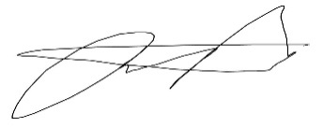



**Kyong Jae Woo, Team Lead & System Integration:** As a member of the system integration team, I had spent most of my time on controls side of the project. I have researched numerous control schemes that are used in exoskeletons especially in EMG driven exoskeleton systems as benchmarks and to gain general knowledge on how the controllers are implemented in various systems. I have come up with two possible controller schemes that can be used in our projects. I am also responsible of helping signal processing group to characterize the EMG signals to the torque values.





# Executive Summary

Signal processing mainly involved research, testing, and analysis. A Shimmer device was used to collect various signal data to determine which would be optimum. From testing and analysis, it was finalized that EMG signals will act as the primary signal source because it can detect the user’s intention to stand early and can implemented under the knee brace. The filtering method for EMG signal was finalized as: remove the mean from the signal and put the signal through a high pass filter, rectify the signal and put it through a low pass filter, and finally normalize the signal for comparison. Tibialis Anterior (TA) was determined to provide the cleanest signal with the earliest detection time out of the useable muscle groups through testing. It was also seen that effort is evident in the EMG signal. The TA is used for more than just STS so additional sensors were required to tell if the user is sitting. It was decided that the EMG with encoder combo will be used. It was also decided that a MyoWare Muscle Sensor with Conductive Fabric will be purchased for further testing and analysis.

Two different controller schemes were investigated: position based controller and torque based controller. It was decided that the torque based controller is the most capable of providing the assistance the user actually requires. The torque based controller used EMG signals to determine the support torque the user needs and compares it to the torque the actuator is producing. It then adjusted the actuator to match the support torque the user needs. This method would require an EMG to torque profile to be created. The hardware that was chosen to act as the controller was the Arduino Uno.

In the mechanical section of this report the preliminary design and the considerations made to arrive at this design are presented. The maximum amount of torque in the knee for a 95th percentile, 65 year old, man is 93 Nm. As per the project requirements, the brace is to provide within the range of 25% to 50% assistance, which equates to 23.25 Nm to 46.5 Nm. A design matrix is utilized to identify the possible components for the major design categories of the mechanical brace. The most important component is concluded to be the actuator, and the three conceptual designs that are developed and evaluated are as follows: (i) linear actuation, (ii) rotary actuation,and (iii) pulling actuation.  Based on a decision matrix, the pulling actuation concept was selected as the ideal candidate to pursue for the preliminary design.  The preliminary design, including calculations to support the feasibility, is completed.  A motor situated on the upper leg winds a cable (creating tension) attached to a linkage which pivots about a joint at the knee.  This in turn creates assistive torque to enable the user to stand up.  The verification of the mechanical design will consist of six major steps: engineering calculation, finite element analysis, prototyping, determining user interaction, design for manufacturing and assembly, and a preliminary digital buyoff.

Potential safety hazards concerning the mechanical, electrical, signal processing and control systems are identified. Mechanical and electrical hazards include mechanical failure of the parts, pinching, burning, and poor ergonomic fit. Hazards regarding signal processing and control include intention detection failure, over-extension of the joint, and sudden torque increase.  To design for sustainability, the design should maximize the use of recyclable materials and the individual parts should easily be replaceable to reduce unnecessary waste.

# Problem Background (Preliminary Needs Analysis)

## Motivation

The Sit-To-Stand (STS) motion is defined as a movement of standing from a chair to an upright posture and it is one of the fundamental activities, along with walking, that most people do in their daily lives. People perform the STS motion on average at least 45 times per day [1]. The load applied to the knee joint during the STS motion is six times greater than that of during walking. Therefore, people with weak leg muscles or knee joints experience pain and reduced mobility [2].

One very common cause of this weakness comes from aging. Aging reduces the flexibility of the knee joint and lowers the range of motion. It also weakens the muscle tissues surrounding the knee joint [3]. Therefore older generations commonly suffer from leg weakness and struggle standing in their daily lives. More than two million people aged 65 or older report the difficulties in getting out of their chairs in United States [4]. This indicates a clear problem that must be solved. Our project looks to help people stand up and sit down.

## Existing Solutions

The most instinctive solution to reduce the difficulty in STS motion is to reduce the load on the joint by using ones arms to push off from the seated position. Most of the traditional assistive technologies such as wall mounted bars, canes and crutches follow this form. The advantages of these devices are relatively low cost, simple design, and for some good mobility. The simple design and function of these devices enables usage in many applications. However using such devices increases stress on the upper body, specifically the arms and shoulders. This can cause secondary injuries on shoulder joints or arm muscles from frequent usage.

Due to the recent developments in robotics and a deeper understanding of biomechanics, more sophisticated solutions to help people with daily tasks such as standing up or walking are being introduced. Many of these solutions can detect the user’s intent to move, and exert mechanical power to assist them with various tasks. Typically, the user’s intent is detected using a sensor and the controller translates the signal into mechanical movement using an actuator. Pressure sensors, electromyography (EMG) sensors, and torque detectors are the common types of sensors used. Linear and rotary actuators are commonly used. However, since the human motion is not purely rotational or linear (rather a combination of both), an in-depth understanding of biomechanics is necessary to design a brace that provides assistance without harming the user. With the current technological availability, pneumatic, hydraulic, and electrical power sources are being considered.

Currently, there are a number of solutions to help people with the STS motion. Although the commercial market for these devices is expanding, there are still many that are in the research and development phase.

ReWalk Personal [5] (Figure 1) is a battery-powered system that utilizes electrical motors with rotary action at both the hip and knee joints. The movement of the device is controlled by the change of the user’s center of gravity which is detected by a gyroscope. For example, when the user tilts forward to indicate their intent to move in a forward direction, the first step is initiated. The repeated tilting of the body generates a sequence of steps which mimics the walking movement.  However, ReWalk is designed for people with lower paralysis and is not designed for people with common knee problems. If a person with functional legs attempts to use the system, it may be awkward because it requires the user to constantly tilt their body to initiate movement. Although ReWalk can assist people with standing up, it is primarily designed for walking. Therefore, this type of solution is excessive for assisting the STS motion because it requires the use of crutches, and user must wear a large battery pack since the additional motor at the hip requires more energy.

|  |  |
| --- | --- |
| https://lh3.googleusercontent.com/4tyUSVrg55cxNNMBJlmw5-7vuENihej2i8duIBHY6C6nkIpZVNSZAugaY4emXkb9QvAciC6ph5CgF_WoK4ZiIJvQFy1U2q2eg8pCVCbyBtAYYuBlrHaa292lNtYj0c505GYIibNlOonbxBA9 | https://lh4.googleusercontent.com/rtvW85Cl-1AB-UBNYN-6-3viULoyrp29JcorD9kDertT7O9B5ZmrZMXQxJPkmlDsEmYaguw1c8k4FMMuyu4yo2xLOvwZ2gTPIGCVlIuXYBwpw9wV2EdpCnXoH3Q26X7roWhUJquVfD6B3ZVv |
| Figure : ReWalk Personal 6.0 [5] | Figure : AlterG’s Bionic Leg [6] |

AlterG’s bionic leg [6] (Figure 2) is a battery-powered system with an electrical motor at the knee joint. The pressure sensor at the heel detects the user’s intent to move and the motor assists the user with extending and flexing of their knee. The device utilizes carbon fiber in most of the structural members to minimize the weight. In addition, AlterG uses a compact lithium-ion battery rated at 11 volts which helps in reducing the overall size and weight of the system [7]. AlterG costs up to 1200 dollars per month to rent [8], which is too expensive for personal use. The high cost is due to the fact that the device has complex features and digital interfaces, as it is primarily designed for use at rehabilitation centres. For example, the bionic leg has functions such as changing the orientation of the display screen, counting and displaying the number of steps taken, and adjusting calibration of the system using the display screen. Although these features are useful, some of the functions can be simplified or eliminated to develop a more affordable system.

## Market Opportunity

According to the US Census Database, the share of population age 65 and older is projected to increase in a number of countries as shown in Figure 3 [9]. In Japan alone, the share of population age 65 and over is projected to be upwards of 40 percent, see Figure 3.  This news is alarming to the governments who will have to allocate an enormous amount of funding for old age security. On the upside, it poses a huge market opportunity because many elderly people suffer from joint problems and will require an assistive device for mobility. In addition, once the share of the elderly population becomes financially unmanageable, the governments will be forced to increase the retirement age. This will likely lead to an increased demand for assistive knee brace devices that are more sophisticated than the existing solutions, and compact so that the users can go about their daily activities at the workplace.

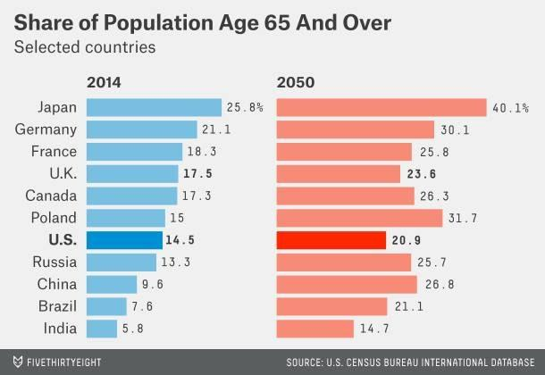

Figure : Projected Share of Population Age 65 and Over [9]

# Problem Description

Knee problems are a growing issue faced by people of all ages that needs to be addressed. The main need statement of this problem is: Design a knee brace that *supplies* mechanical energy *without harming* the user.

## System Block Diagram

The system block diagram for this project can be seen in Figure 4. The core of the system will be the human-brace interface consisting of a controller, actuator, methods of interaction, and a physical attachment of the brace to the leg. The three main inputs to the system, shown to the left of the core, are the signals, electrical energy, and emergency shutdown input. The signals consist of muscle actuation signals, noise, and the power button. The electrical energy will include the power source used to power the system. The emergency shutdown button will be used to allow for user intervention to kill the system in the event of an emergency. The two main outputs to the system are the mechanical energy and wasted energy. The mechanical energy is the torque to assist the motion. Inevitably there will also be wasted energy like friction, vibration, heat, and noise.

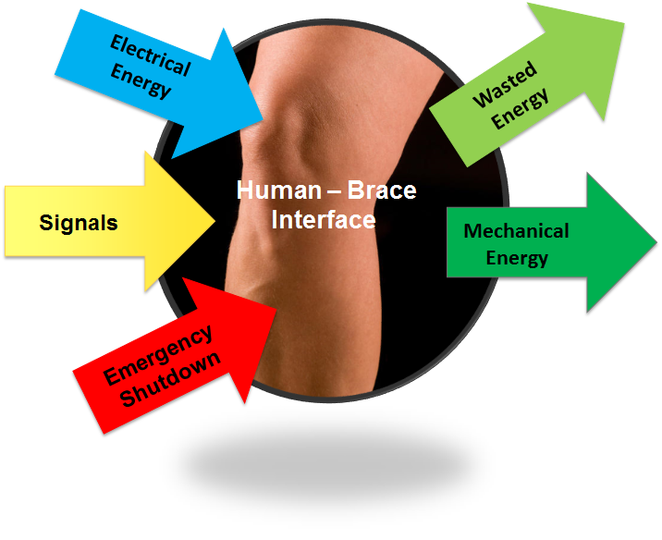

Figure : System Block Diagram

## Function Structure

The primary function of the brace is to supply mechanical energy, and the primary constraint is to avoid harm to the user. The function structure can is shown in Figure5. The primary function can be broken down into two sub-functions, apply assistive torque and detect motion intention. The applied assistive torque sub-function can be broken down to assisting motion and engaging the leg. The design is meant to apply assistive torque to the leg to assist the STS motion and ensure that the knee brace is tight and secure to the leg to avoid slipping. The second sub-function can be broken down even further to process signals. The design is meant to detect the user’s intention to stand and also process the signals to accurately identify the intention.

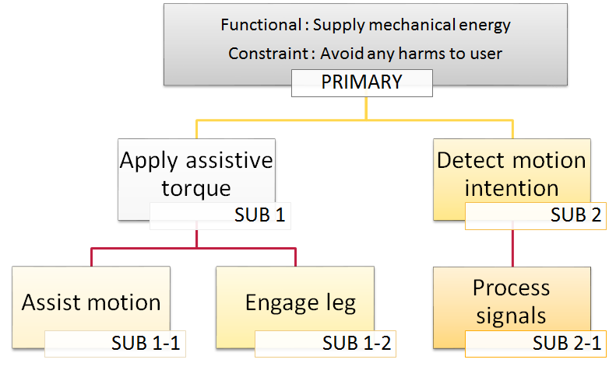

Figure : Function Structure

## Success Measurement

The success for this project will be measured using the following categories: functional requirements, non-functional requirements, and constraint requirements. This section will describe each of these categories in detail. The project requirements can be seen in Project Requirements (Revision 005) in Appendix A.

### Functional Requirements

#### Detect User Intention

The knee brace should use a signal processing system to detect the user’s intention to stand. This system will use EMG signals from the user to detect both the initiation and the intensity of STS motion. A successful system should correctly detect the moment of initiation and should accurately measure the intensity of STS motion that the user is trying to achieve.

#### Supply Adequate Torque to Knee

After detecting the user’s intention to stand, the knee brace should supply adequate torque to assist the standing motion. There are a several actuation methods that will be explored later in the report. This is a very high-torque application so the chosen method should be able to handle this torque. It is important the knee brace movement is as natural as possible. If the movement is jerky, it can hurt the user or cause the user to lose their balance.

### Non-Functional Requirements

#### Ergonomic

This leg brace can potentially be worn for long periods of time. It should be ergonomic and comfortable for the user. A good design will be comfortable to wear even when it is not being used, will not interfere with walking or other non-STS movements, and most importantly will not cause any pain to the user.

#### Manufacturability

Manufacturability is the art of designing products in such a way that they are easy to manufacture. An easy-to-manufacture knee brace will reduce the manufacturing time, and therefore reduce the cost of labour. A design that is easy to make will leave more time for testing and improvements.

#### Aesthetics

This knee brace will most likely be worn over clothing due to its size. Therefore, it should be visually appealing to wear. A user is more likely to wear an aesthetically appealing knee brace that one that is an eye sore. It also adds to the shelf appeal. The user should want to wear the knee brace.

### Constraint Requirements

#### Safety

There are a lot of safety concerns with designing a knee brace. The main limitation for this device is that it cannot harm the user in any way, or exacerbate the ailment of the user. The actuating device must have mechanical and software stops to prevent overextension or overflexion of the joint. There should be safeties in place in the code to terminate actuator movement if necessary. A safety shut off would be ideal to cut power to the actuator if required, or a method to remove the device from the leg in case of an emergency. There are software concerns like an algorithm failure where the motor overdrives, or under-drives.  There are also mechanical concerns such as poor ergonomic fit, parts breaking down, or parts not being able to withstand cyclic loading. Since the system will be live, there is also the risk of electrocution, shock, fires, etc. Furthermore the operating temperature of the battery motor and controller should be limited to make sure the user feels comfortable and does not get burned. A good design will not harm the user in any way.

# Signal Processing

Inputs are essential for the A.B.L.E. device to detect the user’s intention to stand and to determine what torque should be supplied to the actuation device. Sensors will provide analog signals that will need to be processed and analyzed to be useable for the purposes of the A.B.L.E. device. This section will go into the potential sensors that have been considered and show testing data that was used to determine the signal detection devices.

## Background Information

The potential sensors that can be used as inputs for the A.B.L.E. were broken down into three sections: user inputs, mechanical inputs, and biological inputs.

### User Input Sensors

User inputs are signals that manually inputted by the user, directly to the device. User input devices include switches, buttons, and potentiometers. The switch could be used as an ON/OFF switch. The buttons can be used for such things as an emergency stop button or as a stand-up button. The potentiometer acts as a variable resistor and is a dial that can be used to determine intent and intensity. The potentiometer can be used by the user to manually control the speed to stand up.

These sensors can be implemented anywhere that the user can reach them. These sensors are the safest and most accurate method to detect the user’s intention to stand. Also the sensors in this section are the cheapest among the three categories. The drawback for these sensors is that it requires user intervention. The motion can only be controlled by the speed setting. The motion itself may not feel natural to movement since in a normal sit-to-stand the speed can vary.

### Mechanical Input Sensors

Mechanical inputs are signals that are captured from the movement of the user. Inertial measurement devices and pressure sensor devices were considered. Inertial measurement devices include encoders, gyroscopes, accelerometers, and magnetometers. These sensors can provide data about position, speed, acceleration, and the magnetic field, respectively. Hence, by using these sensors, the user’s motion and there corresponding kinematic information can be determined. Inverse dynamics can be used to determine the user’s initiation and torque [10].

Another mechanical sensor that can be used are pressure sensors in the shoe. People apply different pressure patterns when they are walking, sitting, standing, or standing up or sitting down [11]. A pressure sensor must be implemented insole. Similar to the inertial measurement devices, the data from pressure sensors can be used to detect changes in the user’s movement. This also extends the size of the knee brace to extend to the shoe.

The benefit over input sensors is that the user does not need to manually input signals. The data from mechanical sensors are useful in determining the kinematic variables of the motion. They are also more expensive than user input sensors and are easy to implement

### Biological Input Sensors

The biological sensors also do not need the user to manually input signals. The main biological sensor that considered is electromyography (EMG). EMG sensors read the small voltage difference that is created in a muscle [12]. The main non-intrusive method for measuring EMG signals is using devices that are capable of collecting surface EMGs (sEMG) signals [12]. One method of collecting the sEMG is using surface electrodes with wet pads [12]. By placing electrodes over the appropriate muscles, the muscle activity of the user can be read [12]. It is also possible to differentiate between different types of movements (STS, walking, etc.) in the EMG signal since different movements create different patterns and peaks [13, 14].

The main drawback for this signal is that it requires direct contact with bare skin. Also, even for the same muscle, the signal strength can vary from day to day [12]. Also, the biological input sensors are the most expensive sensors among the three groups. However, this method is the most intuitive method because the signal is produced by the user’s body, and muscle contraction can be detected before actual motion [15]. Furthermore, user’s effort can be detected from the EMG signal [11].

#### Electromyography (EMG)

In order to learn how electromyography (EMG) works and where the signals are coming from, a brief overview of cellular biology is required. When the body wants a muscle to contract it sends a signal from the brain, through a nerve to muscle cells. Muscle cells are organized in fibers, as shown in Figure 6 below. When one cell is activated it sends a wave that propagates along the fiber activating other cells.

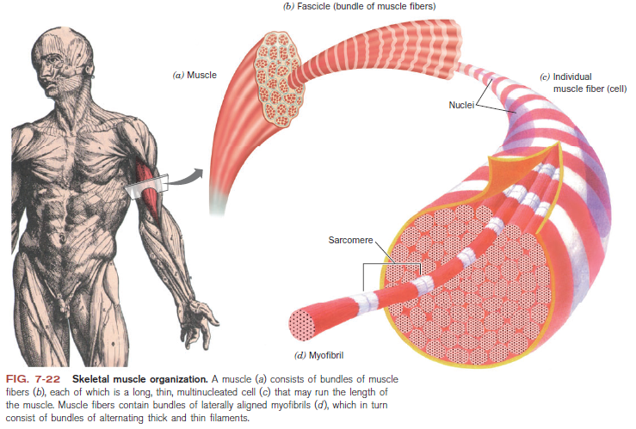

Figure : Skeletal muscle organization [16]. A muscle (a) consists of bundles of muscle fibers (b), each of which is a long, thin, multinucleated cell (c) that may run the length of the muscle. Muscle fibers contain bundles of laterally aligned myofibrils (d), which in turn consist of bundles of alternating thick and thin filaments.

In the muscle cells there is an electrical gradient across the cell membrane created by an ion concentration gradient. There is a much higher concentration of positively charged sodium ions (Na+) outside of the cell than inside, so relative to outside the inside of the cell has a negative charge. When a muscle cell is activated pores open on the cell membrane, Na+ floods into the cell, activates proteins (through a series of reactions), and these proteins will pull against each other, contracting the cell. When many muscle cells are activated at once the muscle contracts. The flood of ions into the cell is called a depolarization. To reset itself, the cell will pump the sodium ions back out again and this process is called repolarization. The cycle of depolarization and repolarization is called an action potential, and is shown in Figure 7 below.

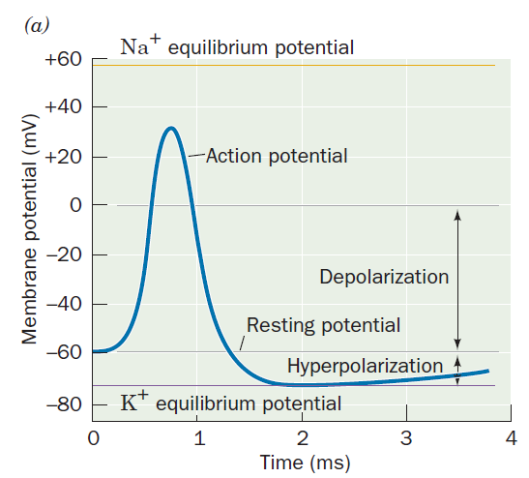

Figure : Action potential of a cell membrane [16]. The neuron membrane undergoes rapid depolarization, followed by a nearly as rapid repolarization resulting in a slight hyperpolarization, and then a slow recovery to its resting potential.

EMG detects the electrical pulse caused by the propagation of the action potential along the muscle fibers. The depolarization zone is about 1-3mm2 and moves at about 2-6m/s [17]. There are two electrodes that you put on your skin to detect the potential difference between the two points. The electrodes are placed parallel to the muscle fibers. Figure 8 below shows how the electrodes detect the signal. At T1 the wave approaches the electrodes, passes under the first electrode at T2 and the second electrode at T4. This creates a bipolar signal. Groups of fibers are called motor units and the electrodes sit on top of many motor units. The potential difference is detected for many motor units at once and the signals are superimposed, see Figure 9.

|  |  |
| --- | --- |
| Figure : Model of action potential detection by electrodes [17]. | Figure : Superposition of motor unit action potentials (MUAPs) to a resulting EMG signal [17]. |

The intensity of muscle contraction is determined by the frequency of the action potentials. A stronger muscle contraction has a higher frequency of cellular contractions, more action potentials and the summed action potentials give a large EMG signal amplitude. Using EMG the effort that the muscle is exerting can be directly related to the amplitude of the EMG signals. A raw EMG signal is shown in Figure 10 below.

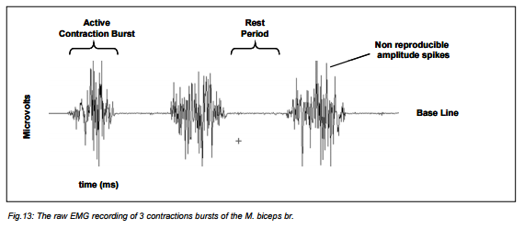

Figure : Raw EMG signal of three static contractions of the biceps brachii muscle [17].

Figure 10 shows a clear EMG baseline when the muscle is at rest, and a clear signal when the muscle is contracted. A healthy muscle should not have a significant EMG signal while relaxed. Since different motor units are activated randomly at different points during each contraction, and they are different distances away from the electrodes, the EMG signal is always slightly different, giving random shapes to the EMG signal, for example if two or more motor units fire at the same time and are located near the electrodes they produce a stronger superposition spike than two that are farther away. Filters and algorithms covered in later sections turn the raw EMG into usable data.

## Primary Experimental Testing

From the background information shown above, it was concluded that EMG had the greatest potential to act as the primary sensor. It was shown that it is capable of detecting the user’s intention to stand, and the muscle effort the user is exerting when performing an STS. Inertial sensors like accelerometers gyroscopes, and position sensors are also of interest because they could be used to provide kinematic data from the user. Pressure sensors are also considered because they have the capacity of detecting the user’s intention to stand.

The first muscle group that was tested was the Rectus Femoris [18]. Pressure data for walking, sitting, and STS was available from research performed by Kyongjae Woo [11].

### Experimental Apparatus and Testing Procedure

For this preliminary testing, a Shimmer device was used (courtesy of Dr. Tung). The Shimmer is capable of providing axis angle, accelerometer, gyroscope, and EMG signals.

#### Experimental Apparatus

* Shimmer unit
* Google Nexus 7 tablet w/ Shimmer app – to record data
* MATLAB 2015a
* 3 Electrode wet pads and their corresponding wires

#### Procedure

1. Determine where electrodes for the muscle of interest would be placed via Seniam.org recommendations. Determine a nearby bony area that can be used as the ground.
2. Prepare the skin for electrode placement
   1. Shave (if necessary)
   2. Clean the skin by wiping down the skin with alcohol – be very thorough as this step reduces the impedance between skin layers [19]
3. Use Seniam.org recommendations to mark the location of the electrodes
4. Place the electrodes at their marked location and record the inter-electrode distance
5. Place the last electrode on the common ground (Figure 11 shows the final set up for the Rectus Femoris)
6. Sync the Nexus 7 tablet to the shimmer device with the Shimmer app.
7. Set and record the sampling rate with the shimmer app
8. Begin testing and record using the shimmer app
9. User performs 3 normal STSs and then 5 fast STSs
10. Export the data to MATLAB and post-process as required.

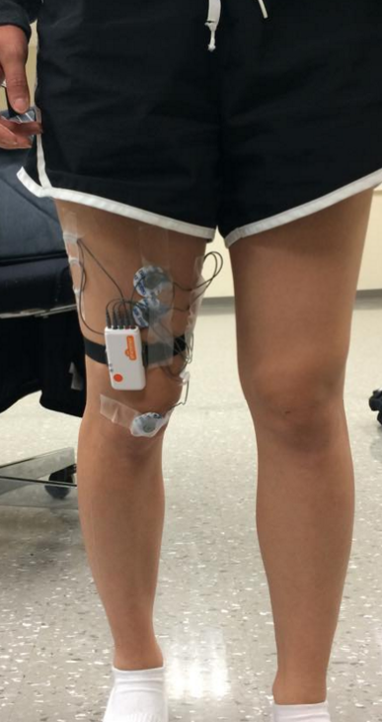

Figure : Shimmer and electrode place for the Rectus Femoris

## Filtering Techniques

The shimmer provides raw signals for analysis. These signals are very noisy and contains trends. This data is not usable for comparison so it is required that the data be filtered and processed. The following section will go over the filtering methodology that was used to filter the signals.

### Raw Signals

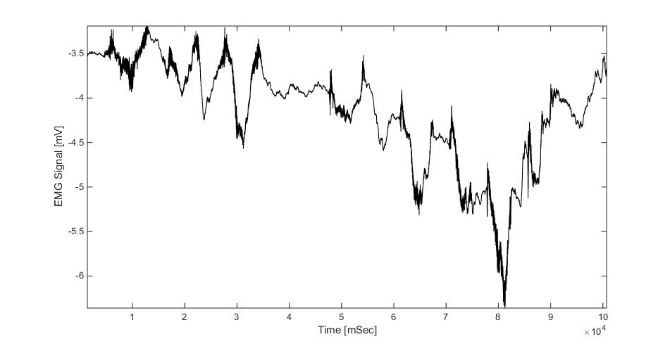

Figure : Raw Rectus Femoris EMG signal

Figure 12 show the raw signals collected from the Rectus Femoris. Comparing this data to the video of the testing seen in the Exhibit**,** it can be seen that highly dense areas are generally where a sit-to-stand or a stand-to-sit occur. It is also evident from that data points that there is a zero offset and the mean of the data is not zero. This data is not useable in the current format and filtering is required before it can directly be compared to the other signals.

### Removing the Offset and High Pass Filtering

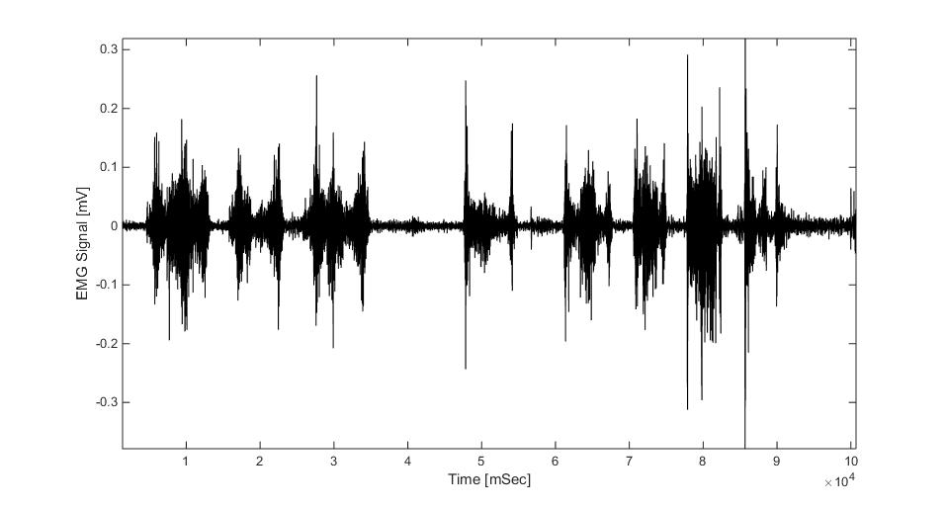

Figure : Normalized – Mean Removed Rectus Femoris EMG Signal

Figure 13shows the EMG signal after a High Pass 4th order Butterworth filter at 15 Hz was applied to raw signal minus the mean. From this dataset, the muscle activation from a sit-to-stand followed by a stand-to-sit are evident by the high peak areas. The eight sit-to-stand-to-sits can be discerned from the graph.

The trend seen in the EMG signal can be caused by electrical interference [20]. The offset can be removed by finding the mean of the signal and removing it from every data point in the signal [20]. This step is important because the filtered data can be inaccurate if this step is skipped [20]. The signal mean should be zero before proceeding to use high pass filters.

A high pass filter is important because it is capable of removing noise from low frequency sources that contribute signals to the overall sEMG signal [20]. Noise sources include power line noise, cable motion artifact, motion artifact, etc. [20]. High pass filters attenuate frequencies below the cut-off, and retains frequencies above the cut-off [20]. The Butterworth filter was chosen because it is best suited for requiring preservation of amplitude linearity in the passband region [21] .The useful range of EMG signals recommended is 5Hz to 450Hz [21]. The cut-off frequency of 15 Hz was chosen for remove the noise.

The filtering for this section was done through MATLAB using the MATLAB ‘butter’ and ‘filtfilt’ function, and the code can be seen in Appendix D.

### Rectification, Low Pass Filter, and Normalization

*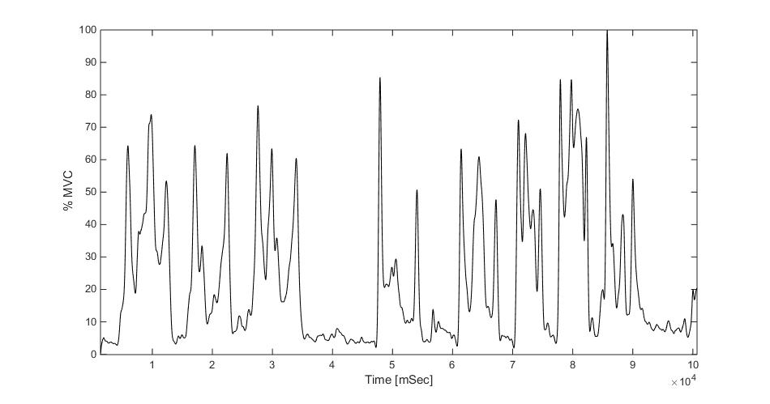*

Figure : Normalized – LPF – Rectified – HPF – Mean Removed Rectus Femoris EMG Signal

Figure 14shows the filtered data from further filtered by a low pass 4th order Butterworth filter applied at 5 Hz. From this dataset, it is evident that an overall envelope of the HPF was returned.

A low pass filtered cannot be applied with first rectifying the signal [20]. The Butterworth filter was chosen for the same reasons as above. The low pass filter returns the envelope of the provided data [20]. The recommended high cut-off frequency for the Rectus Femoris is 600Hz [21]. With the low pass filtering with the cut-off frequency of 600Hz, the visible difference was not evident. Thus, the low pass filter to reduce the higher frequency noise step was unnecessary at this stage. Nevertheless, low pass filter was needed to smooth the high pass filtered data to get the envelope. The cut-off frequency used for smoothing the data via low pass Butterworth filter is 5 Hz. The cut-off frequency was chosen to clearly display the envelope.

The filtering for this section was done through MATLAB using the MATLAB ‘butter’ and ‘filtfilt’ function, and the code can be seen in Appendix D.

The data was normalized because it makes the resultant signal comparable to signals collected from different days and trials. Normally signals are normalized against the Maximum Voluntary Contraction (MVC) value that the subject creates during testing. The MVC was not collected during this trial so the max EMG value collected was used.

## Primary Testing Results

The primary EMG data set collected was filtered using the methodology seen above in Section 3.3.The remaining data will be shown unfiltered, as is from the Shimmer device. Although, the inertial signals were not configured relative to any coordinate system, they are presented in this section as a purely visual reference. The STS motion will be visually evaluated in the following sections from the collected signals to determine which would be the best sensor for detecting the user’s intention to stand.

### Axis Angle Signals

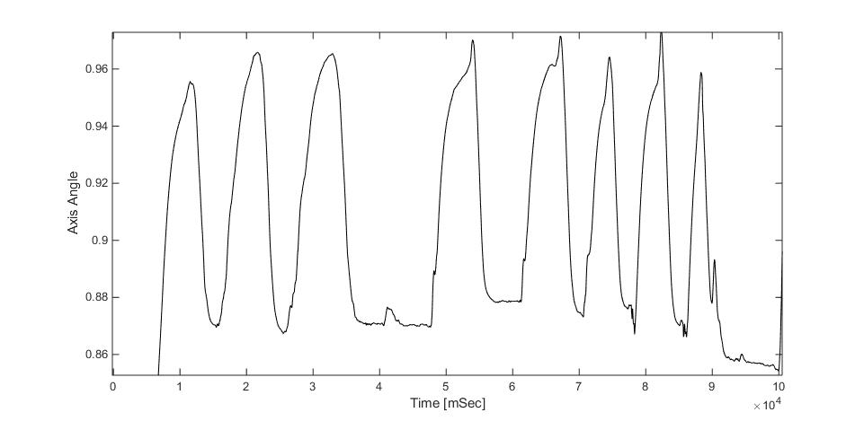

Figure : Axis angle signal data

Figure 15 shows the Axis Angle data for the STS to motion. The axis angle increases for a sit-to-stand and decreases for a stand-to-sit. There is a clear different in amplitude for when the user is standing and when the user is sitting.

### Gyroscope Signals

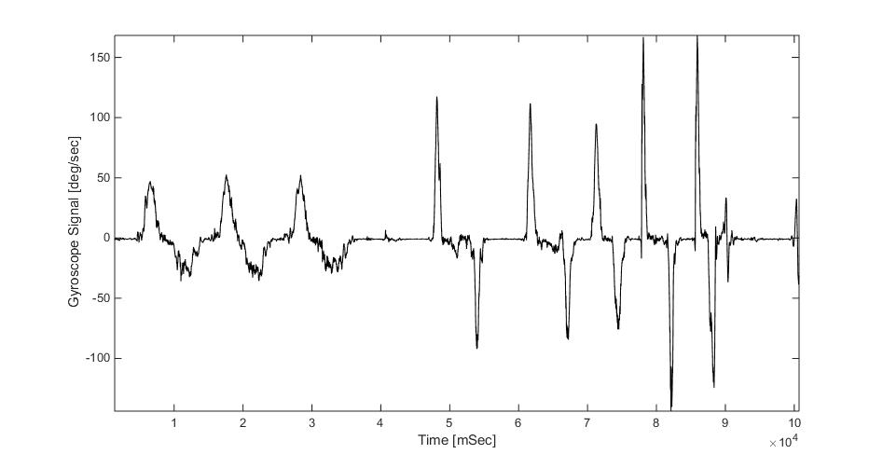

Figure : Gyroscope signal data

Figure 16 shows the collected gyroscope signals. It is evident that the signals increase above the horizontal axis during a sit-to-stand and decreases below the horizontal axis for a stand-to-sit. It is also evident that the user’s speed varies during a sit-to-stand motion. The early part of the graph shows the user standing up normally, the final part shows the user standing up quickly. The speed of the STS is very clearly seen as amplitude in this graph. Higher speeds have higher amplitudes. The faster STS also have shorter time periods. This is expected because the faster STS time period is shorter. This sensor is a good sensor for detecting the user’s speed in standing.

### Accelerometer Signals

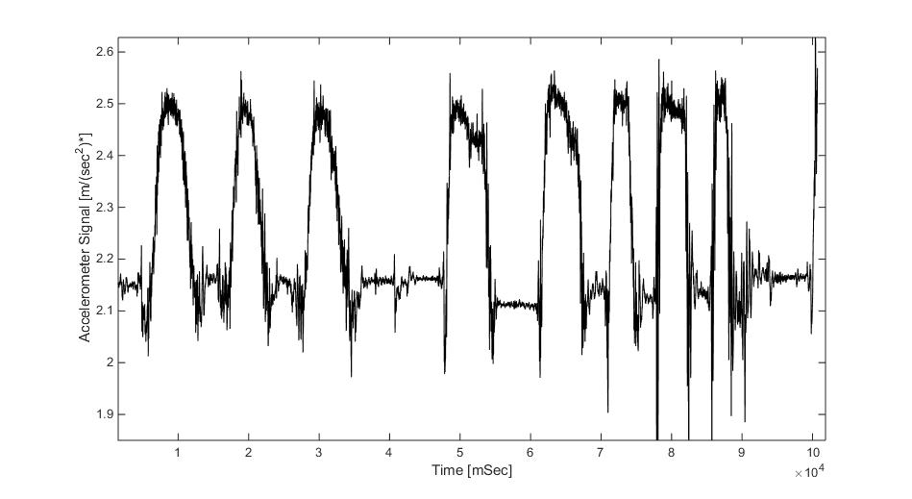

Figure : Accelerometer signal data

Figure 17shows the collected accelerometer signal data. It is evident that the signal amplitude increases during a sit-to-stand and decreases during a stand-to-sit. The amplitude of the accelerometer data fluctuates about a certain set value when the user is sitting and a different set value when the user is standing. The faster STSs feature steeper increasing slopes. Therefore, the standing mean value is reached sooner.

### Rectus Femoris EMG Data

**

Figure : Filtered Rectus Femoris EMG data

Figure 18 shows the Rectus Femoris EMG data. The muscle activity periods are clear from this data. The regions of high amplitude show the muscle activity during a sit-to-stand and a stand-to-sit. There are eight high amplitude periods corresponding to the sit-to-stand-to-sit periods. There is very little muscle activity when the user is not moving. The sit-to-stand is hard to differentiate from the stand-to-sit in this data. This could be due to poor electrode placement.

### Pressure Sensor

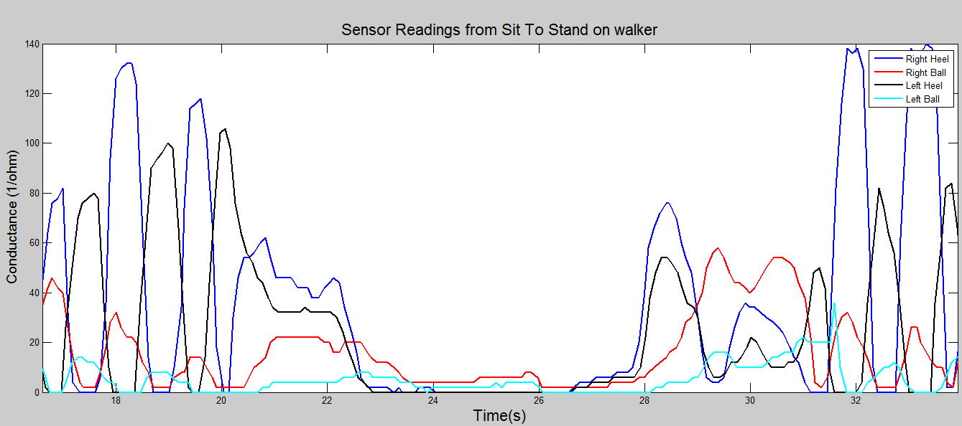

Figure : Pressure sensor readings for sit-to-stand [11]

Figure 19 shows data from pressure sensors placed in the both shoes at the heels and balls of the feet. The early part of the graph shows walking. The middle part shows the user sitting. The final part showcases the user performing a sit-to-stand. From this graph it is evident that pressure in the heels alternate when the user is walking. It is also evident that pressure in the heels overlap during a sit-to-stand. This is a good sensor for detecting the user’s intention to stand and determining the movement of the user.

### Conclusions

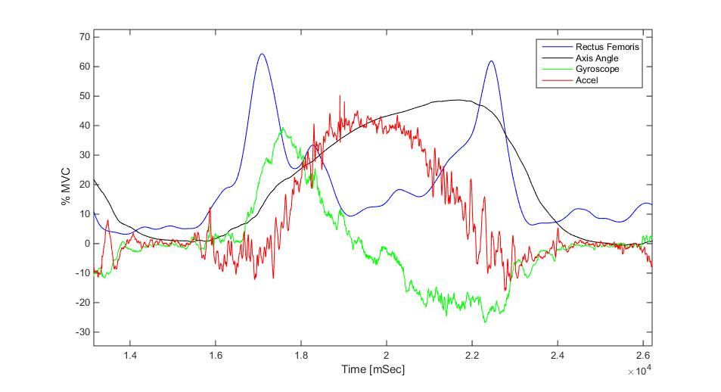

Figure : STS data comparison for all shimmer sensors

Figure 20 shows a sit-to-stand-to-sit section overlaid for each of the sensors from the shimmer device. The plots shown in this graph have been vertically scaled and shifted so the data can be shown overlain (vertical axis is not to scale). From this graph it is evident the EMG signal starts to increase before any of the inertial sensors.

From this testing, it can be concluded the EMG signals can show the user’s intention to stand before an IMU sensor. This means that the EMG signal shows signal data before motion and this can be used to capture the user’s intention to stand. The pressure sensor is capable of showing the user’s intention but the data could not be correlated to determine which detected the motion first. However, pressure sensors would extend the scope of the knee brace to include the shoe. It was preferable to focus the scope on the knee brace. From this it was concluded that EMG signals would be used as the primary signal source, and further research is required to determine which muscle group would provide the best signals.

## Initiation Muscle Determination

It has been concluded that EMG signals can show the user’s intention to stand prior to an IMU sensor. It was then deemed necessary to investigate alternative muscle groups and see which muscle groups would provide the cleanest signals and the earliest detection time. The MATLAB code to create the plots in this section can be seen in Appendix D.

### Which muscles to use

There are many muscles that are involved in the STS motion but only some are useful for giving an EMG signal. There have been multiple papers that investigated the use of EMG during STS and each have used a different set of muscles to detect EMG signals. A short literature review has been performed of to determine which muscles give the best EMG signal.

Table : Literature review of STS studies using EMG and which muscles are studied. Roebroeck et al., 1994 [22], Goulart and Valls-Sole, 1999 [23], He et al., 2007 [24], Fleischer and Hommel, 2007 [25], Cuesta-Vargas and Sanchez, 2013 [26].



Each study uses a different set of muscles but the data indicates the four best muscles to use for sEMG detection of STS movement are rectus femoris, vastus medialis, biceps femoris, and the tibialis anterior.

### Where to Place Sensors

In order to get the best possible signal using surface EMG (sEMG) there are two factors that can easily be changed, the selection of the electrode, and the location of the electrode. The location of the electrode is crucial in order to minimize crosstalk, diffuse signals from co-active adjacent or inactive muscles [27]. A resource for location and electrode type is the SENIAM project, a partnership of sixteen groups from nine European countries covering the main aspects of sEMG use.

The placement of electrodes is based on using bony landmarks on the body and the position given is meant to be the center of the two electrodes. Table 2 below outlines the locations and Figure 21 shows a visual location of each of the muscles. All of the information provided by SENIAM is in Appendix A.

Table : Electrode location based on SENIAM guidelines

|  |  |
| --- | --- |
| **Muscle** | **Location** |
| Rectus Femoris | The electrodes need to be placed at 50% on the line from the anterior spina iliaca superior to the superior part of the patella. |
| Vastus Medialis | Electrodes need to be placed at 80% on the line between the anterior spina iliaca superior and the joint space in front of the anterior border of the medial ligament. |
| Tibialis Anterior | The electrodes need to be placed at 1/3 on the line between the tip of the fibula and the tip of the medial malleolus. |
| Biceps Femoris | The electrodes need to be placed at 50% on the line between the ischial tuberosity and the lateral epicondyle of the tibia. |

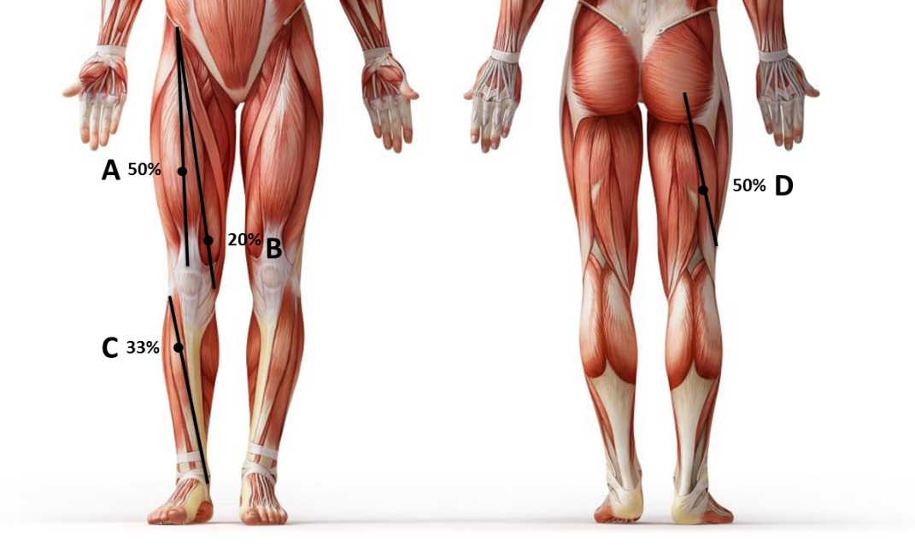

Figure : Electrode location based on SENIAM guidelines. A – rectus femoris, B – vastus medialis, C – tibialis anterior, D – biceps femoris.

### Muscle Groups of Interest

The procedure shown above was used again but this time the user was instrumented with two shimmer devices with electrodes set up in their ideal position (recommendations from Seniam.org) to record data from the following muscle groups: Rectus Femoris, Biceps Femoris, Tibialis Anterior, and Vastus Medialis. These muscle groups were deemed to be of interest during the research phase and that data can be seen earlier in the report. It was decided that new data from the Rectus Femoris would be collected again since the sensor positioning was not good during the first trial.

The subject walked slow for 15 seconds, walked fast for 15 seconds, stood still for 30 seconds, sat still for 30 seconds, sat while fidgeting for 30 seconds, and performed eleven sit-to-stand-to-sits. The data collected was filtered using the procedure shown in Section 3.3.The cut off frequency from

Table 3 were used as the reference for corresponding muscles.

Table : Filter cut off values for the muscles of interest

|  |  |  |  |
| --- | --- | --- | --- |
| **Muscle** | **Low Cut-off (Hz)** | **High Cut-off (Hz)** | **Source** |
| Rectus Femoris | 5.5 | 450 | [21] |
| Biceps Femoris | 20 | 450 | [28] |
| Tibialis Anterior | 6 | 400 | [29] |
| Vastus Medialis | 20 | 450 | [28] |

#### Rectus Femoris Filtered EMG Data

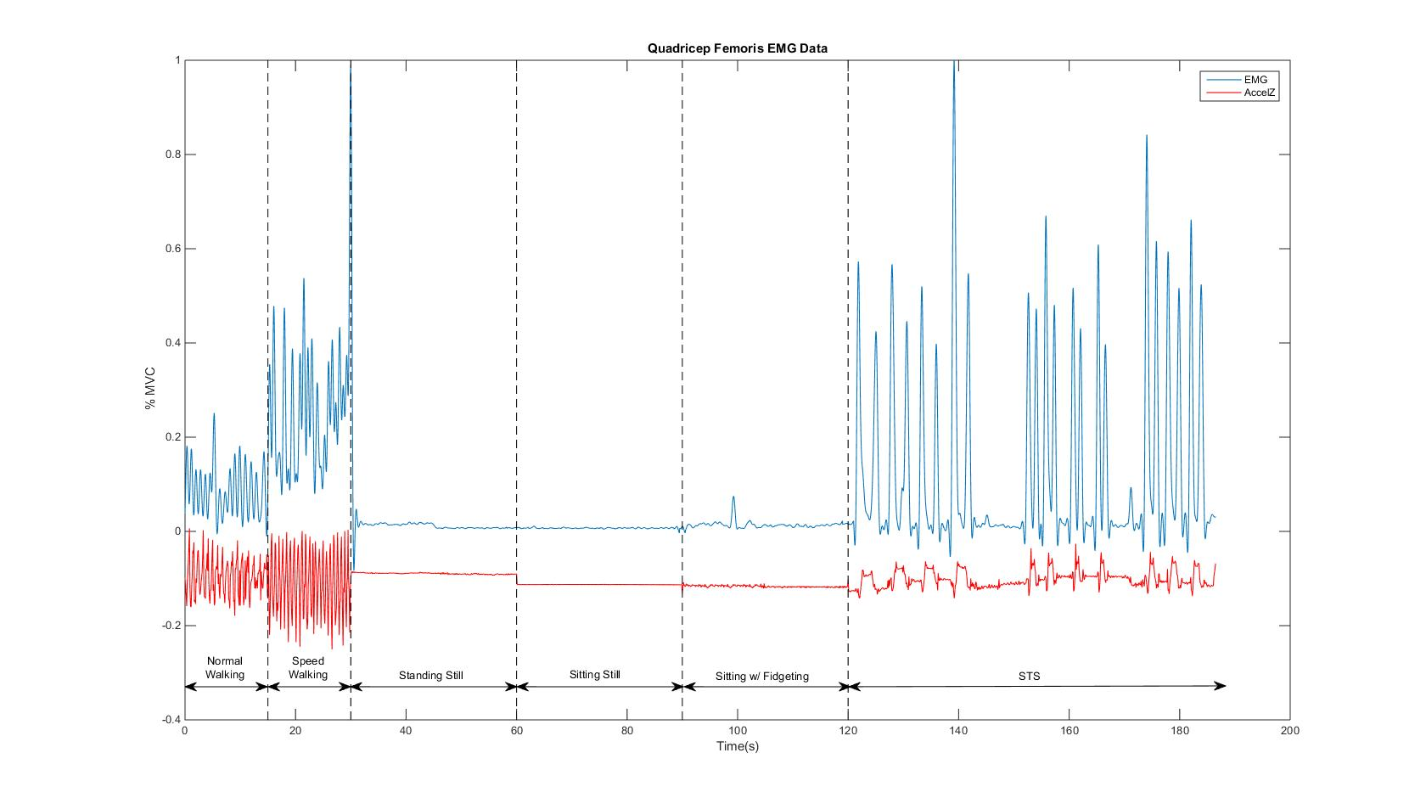

Figure : Second Rectus Femoris EMG Data

Figure 22shows the filtered Rectus Femoris data and accelerometer data. The accelerometer data is shown because it is an inertial sensor and can show changes in elevations. It also shows clearly when an STS motion occurs. From this figure, it is seen that this set of EMG data is much cleaner than the previously collected signals. There are clear peaks from each sit-to-stand and stand-to-sit. There are also relatively little noise when the user is standing still, sitting still, and sitting still and fidgeting. It can also been see that the STS peaks are higher than when the user is walking slowly or walking quickly. It is also seen that the peaks during speed walking are higher than when the user is walking normally. As STS motion requires higher joint moment than walking motion, the higher picks in EMG signal suggests that the information on muscle effort can also be generated from the EMG signals.

#### Biceps Femoris Filtered EMG Data

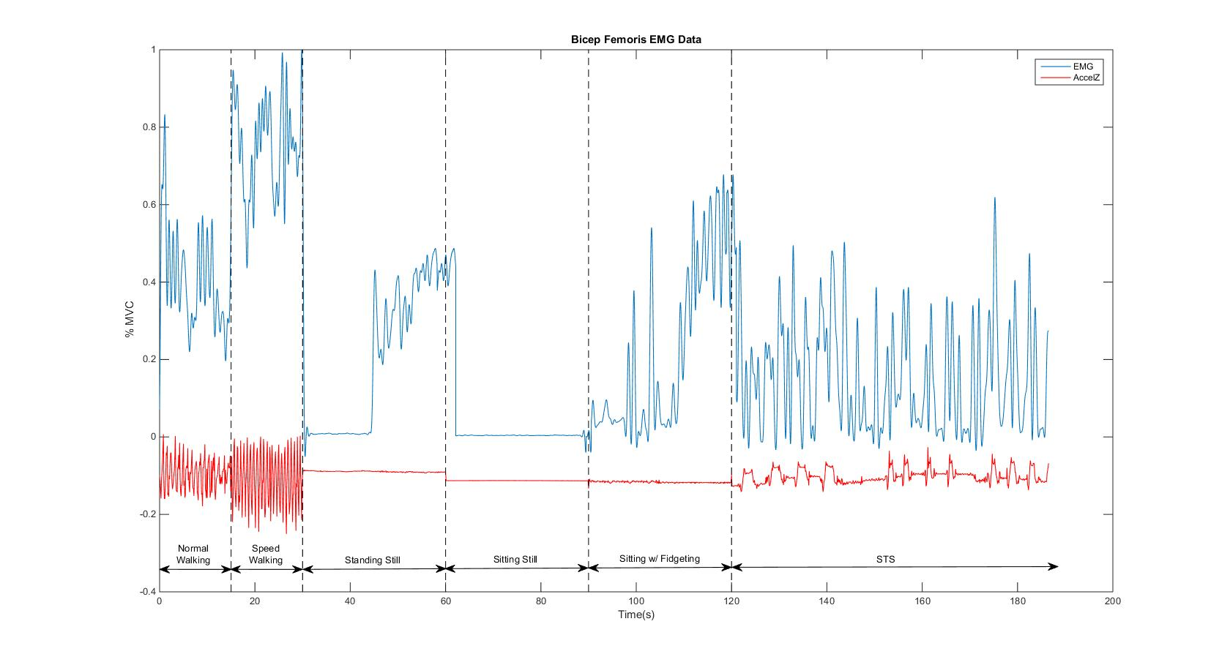

Figure : Biceps Femoris Filtered EMG Data

Figure 23 shows the filtered EMG data for the Biceps Femoris. The signal, post-filtering, is still very noisy. There are peaks higher than STS when the user is just fidgeting. It is also very hard to determine within the noise where the STS occurred. For these reasons, this muscle cannot be used as a signal source.

#### Tibialis Anterior

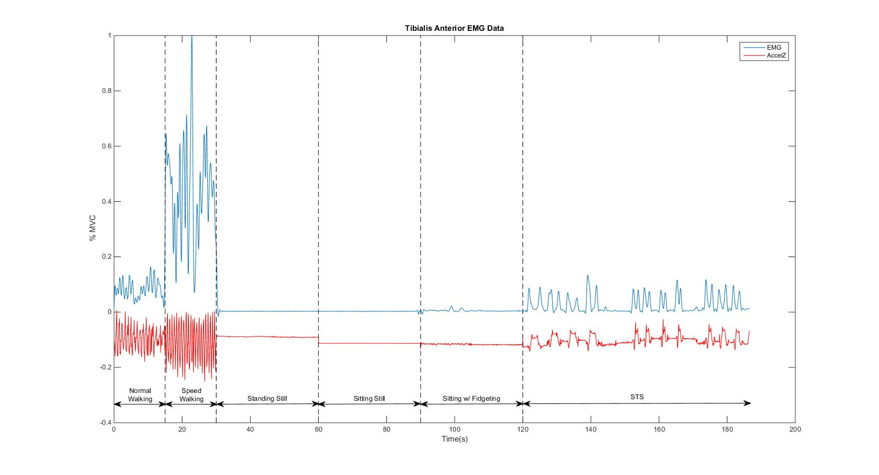

Figure : Tibialis Anterior Filtered EMG Data

Figure 24 shows the filtered EMG data for the Tibialis Anterior. This signal is very clean post processing. There are very little to no peaks when the user is standing still, sitting still, and sitting while fidgeting. There are clear spikes for each sit-to-stand and stand-to-sit. Effort can cleanly be seen in walking because speed walking produces higher peaks. STS peaks are much longer than the ones in the Rectus Femoris.

#### Vastus Medialis

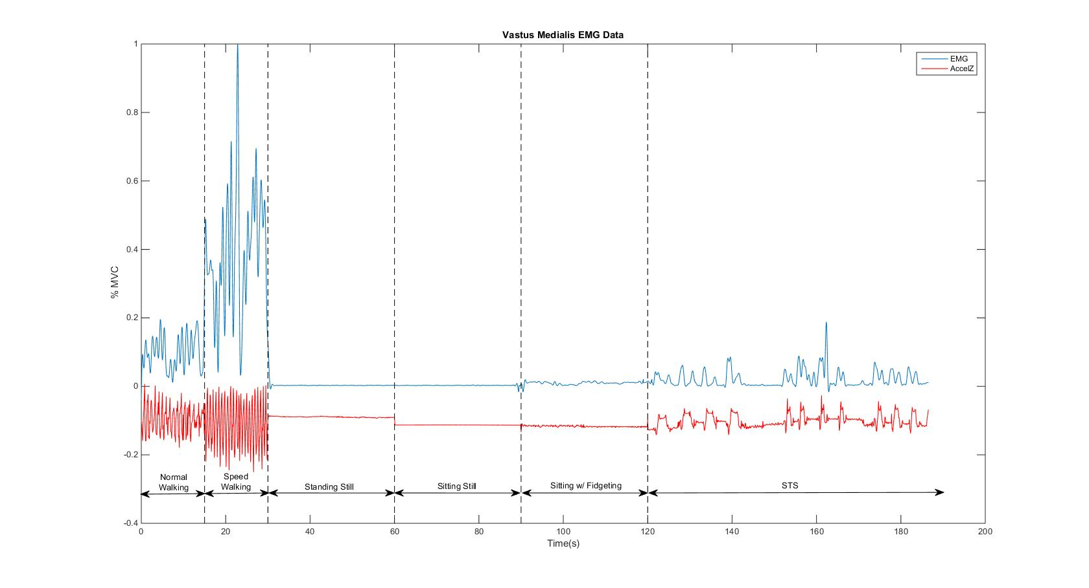

Figure : Vastus Medialis Filtered EMG Data

Figure 25 shows the filtered EMG data for the Vastus Medialis. This signal is also very clean after signal processing. There is more noise when the use is fidgeting then when sitting still but the max peaks are relatively low. The signals are not as clean as the ones from the Tibialis Anterior.

### STS - Tibialis Anterior

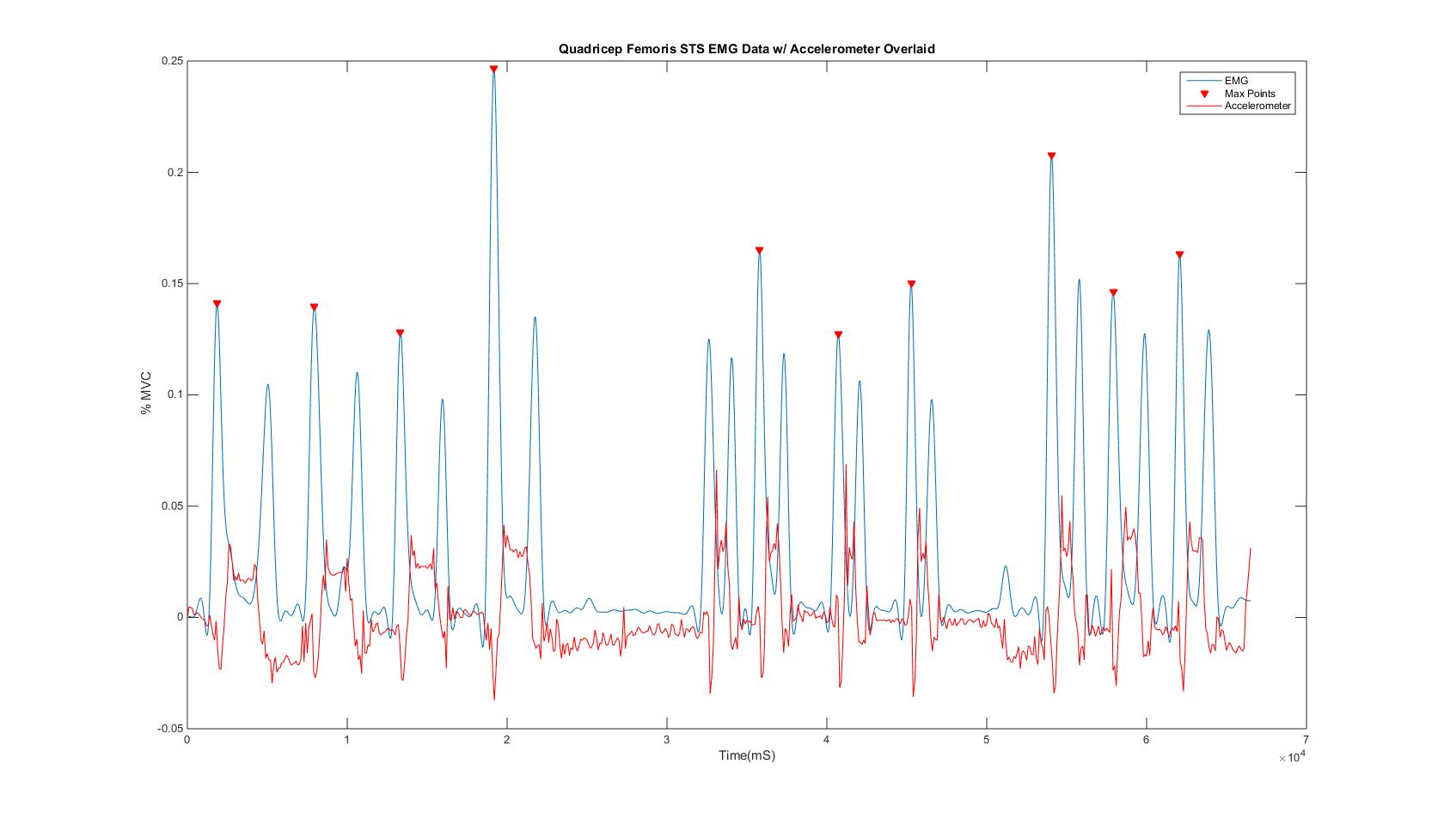

Figure : Tibialis Anterior filtered EMG data for STS

Figure 26 shows the STS data from the Tibialis Anterior with the accelerometer data overlaid for reference. The accelerometer data is not to scale. From this plot a couple of things can be seen. The maximum amplitudes of a sit-to-stand peak is higher than that of a stand-to-sit peak. This can be explained by the fact that it takes more effort to stand than sit because when people sit, they use their muscles to slow them down. Also here it can be seen that the STS data peaks before the accelerometer detects motion. This is because the muscle myoelectric signals are delivered to the muscle, before it actually contracts [15]. The user would output their maximum effort to begin moving so the EMG signals peaks before the accelerometer. This can also explain why knee torque is maximum at seat-off. The accelerometer detects motion before the EMG signal for a stand-to-sit. This can be explained as gravity initially helping the user sit. The user activates their muscles after they start moving to slow the sitting motion.

### STS Start Time Comparison

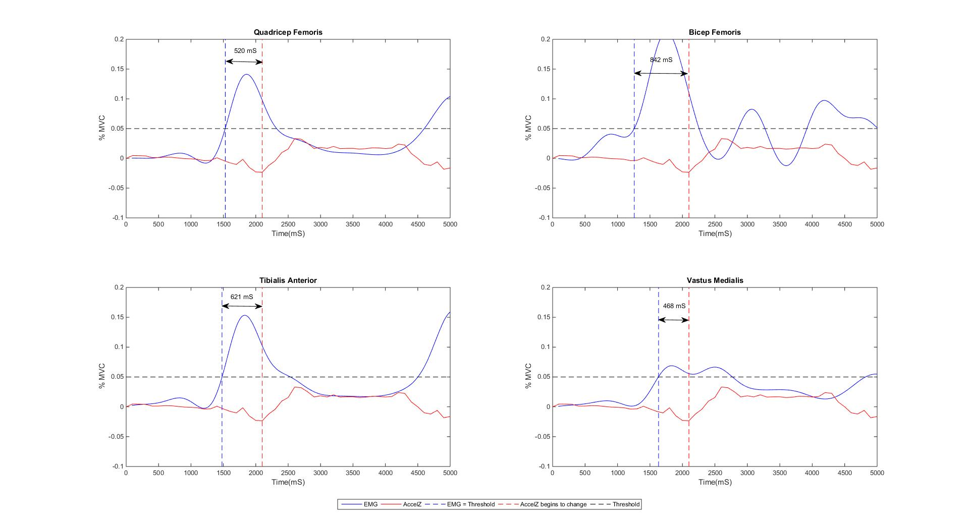

Figure : Muscle groups of interest early detection time

Figure 27 shows a close up of one STS peak for the muscle group graphs shown above. A common threshold was used with a common accelerometer start point to determine how early the EMG signal detects motion. From this analysis, it was determined that the Biceps Femoris is the first muscle to detect the motion at 842 mSec. However, this muscle is very noisy, and the early detection point could have been noise. The second muscle to detect the motion is the Tibialis Anterior at 621 mSec. This muscle as shown earlier gave a very clear signal. Here it is also evident that the Vastus Medialis and the Quadriceps Femoris had a very clear parabolic shape for the STS motion.

### Conclusions

From the above analysis, it can be concluded that the Tibialis Anterior gave the best EMG signal data. It had the second earliest detection time with a very clean signal. The muscle with the earliest detection time was the Biceps Femoris but that had a very noisy signal and could not be used. Also, Vastus Medialis and Rectus Femoris could also be used at the cost of 100-150 mSec detection time. Therefore detecting of STS initiation will be based on the EMG signals from the Tibialis Anterior. Throughout the analysis, it was also suggested that the EMG signals can be used to estimate the user’s effort or intensity. Further studies will be conducted on this for possible applications toward the project.

## Decision Matrix

EMG is the measurement of the potential difference of muscle contraction [12]. The current muscle of choice is the Tibialis Anterior. That muscle is used in other activities than just the sit-to-stand, such as walking, and stand-to-sit. These activities can result in false positives if just a threshold method is used. This problem can be circumvented by utilizing pattern recognition methods or by adding additional sensors to indicate the user is in fact sitting. The combinations that were considered were EMG alone, EMG with a pressure sensor insole, EMG with an IMU sensor, and EMG with an encoder.

The pressure sensor can tell if the user is applying pressure at their heels and can differentiate between when the user is sitting and when the user is beginning to perform the STS. The drawback of this is walking creates higher pressures so either the scope needs to be extended to include both shoes or some pattern recognition must be done. An IMU and encoder can be used to provide user orientation. The drawback of an IMU is that it must be set relative to something. The drawback of encoders is that they could encounter a growing positioning error unless they are reset or calibrated. Also, if a motor is used, an encoder is easier to incorporate at the motor end.

A decision matrix was used to help decide between the various sensor combinations. The decision matrix can be seen in Table 4**.** Each criteria was assigned a weight based on importance. Then each option was given a score out of 5. The decision matrix algorithm was then used to determine which option was the ideal choice. The percent difference between the highest score and the alternative options was also calculated. This is because the definite winner would have at least a 10% lead.

Table : Signal processing decision matrix

|  |  |  |  |  |  |
| --- | --- | --- | --- | --- | --- |
| **Criteria** | **Weighting** | **EMG** | **EMG + Pressure Sensor** | **EMG + IMU** | **EMG + Encoder** |
| Accuracy of Pre-estimation | 40 | 3 | 4 | 5 | 5 |
| Weight / Size | 10 | 5 | 2 | 5 | 5 |
| Complexity of Design | 20 | 5 | 2 | 3 | 5 |
| Cost | 10 | 5 | 2 | 3 | 4 |
| Ergonomic Fit of Design | 10 | 5 | 3 | 5 | 5 |
| Aesthetics | 10 | 5 | 3 | 5 | 5 |
| **Total** | **100** | **420** | **300** | **440** | **490** |
| **Ranking** | | **3** | **4** | **2** | **1** |
| **% Difference** | | **-14%** | **-39%** | **-10%** | **0%** |

From the decision matrix seen in Table 4, it is seen that the winner is the EMG sensor plus the encoder. The encoder was mainly chosen because it can sometimes come coupled with the motor and actuator, and is necessary to properly control actuator unit. The EMG sensor plus the IMU sensor also has a good score but is required to be separately purchased, and would require additional computational time if used. Other sensors that are currently planned for the brace are an ON/OFF switch, and an Emergency Shut-Down button as a safety precaution.

Other necessity components required for the projects are: EMG electrodes, cables, battery. For proper testing and troubleshooting purposes: EMG skin preparation equipment, multimeter and oscilloscope are being considered.

## EMG Signal Hardware Selection

There are not a lot of hardware that are capable of providing the EMG signal, compatible with the chosen controller (discussed later in the report), and available in Canada for purchase. There are two main sensors that could be used for the purposes of this project: Muscle Sensor v3, and the MyoWare Muscle Sensor. The electrical specifications for both are very similar and appropriate for the design and controller.

### Muscle Sensor v3

The Muscle Sensor v3 is designed to be used directly with the controller. The sensor outputs high pass filtered, amplified, rectified, and low pass filtered which results in smoothed EMG signal that can be used with the analog-to-digital convertor in the microcontroller [30]. The electrodes are connected via separate wires so they can be placed wherever they are required. The Muscle Sensor v3 costs $64.09 CAD before tax on RobotShop [31]. This sensor can be seen in Figure 28.

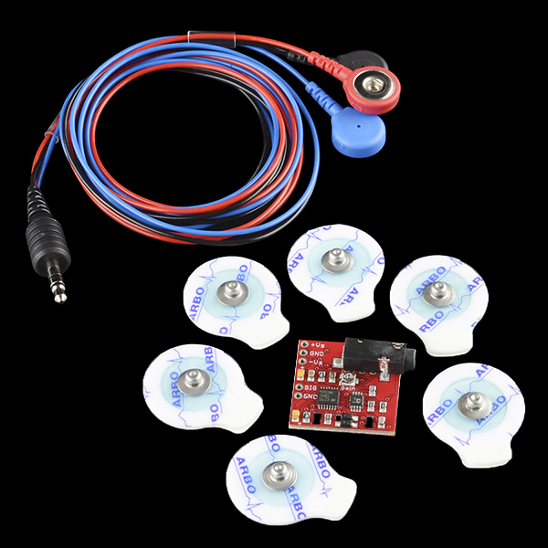

Figure : Muscle Sensor v3 [31]

### MyoWare Sensor

MyoWare, on the other hand, could be in direct contract with the sensor itself (no additional wires required to connect the electrodes to the sensor). However if the board does not fit for the application, there are pins on the circuit board that can be connected to electrodes like the first sensor. The MyoWare is also capable of outputting raw EMG signals [31]. This is beneficial in case the filtering technology used is not sufficient for this application. The MyoWare Muscle Sensor costs $48.71 CAD before tax on RobotShop [32]. This sensor can be seen in Figure 29.

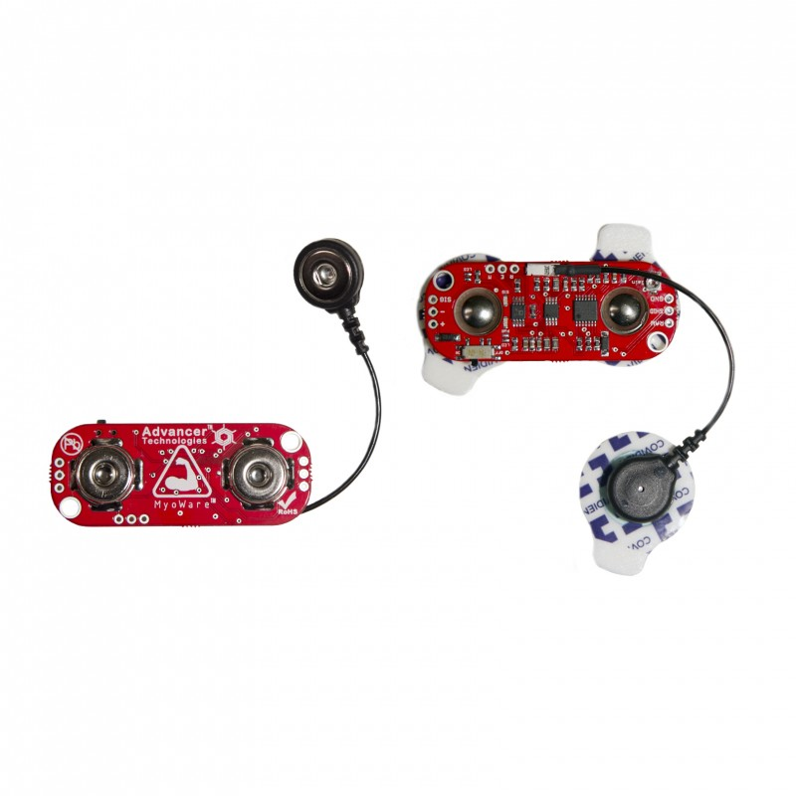

Figure : MyoWare Muscle Sensor [32]

### Conductive Fabric

The traditional EMG electrode can be placed anywhere on the body because of its adhesive component. However, this makes removing the electrodes painful. The wet pads are also not reusable so it can get costly to keep replacing the electrodes. It can also irritate the skin from constant adhesion and removal. Conductive fabric can be used to mitigate this issue. Conductive fabric do not require adhesion and keep worn, and taken off without pain. The conductive fabric can also be incorporated into the brace design. The main benefit of the conductive fabric is that it is reusable. The major downside of the conductive fabric is the signals could be noisier than the wet electrode since it is less concentrated at a point. Since the final muscle of interest has been determined, the conductive fabric can be sown into a larger fabric such that the fabric lines up with the location where the electrodes should be placed. The conductive fabric costs $11.09 CAD on RobotShop [33].

### Final Hardware Decisions

Due to the similarities in the two sensors, it is difficult to select the optimal sensor. The hardware filter quality is particularly valuable for this project since it will reduce the delay due to software filtering and computational time. Both of these sensors are good in terms of hardware filtering. However, the MyoWare has the ability to send out the amplified raw signal if the hardware filtering is not sufficient to allow for software filtering. It is also cheaper than the Muscle Sensor v3. Therefore, it was decided that the MyoWare sensor would be purchased for this project. The electrical specifications for this sensor is listed in Appendix C.It was also decided that a conductive fabric would be bought for testing because it is relatively inexpensive and has potential benefits that would be useful.

# Controller Design

## Overall System Schematics

The flow of the overall system is shown in Figure 30. From the operator end, signals (EMGs) are read through the sensors. These signals are filtered and amplified to reduce the noises and to maximize the usefulness of the data. Then, the processed signals are fed into the microcontroller. Based on the control scheme and the intention detection algorithms, the controller sends corresponding control signals to the actuator/motor unit so that the desired assistive motion can be provided to the operator.

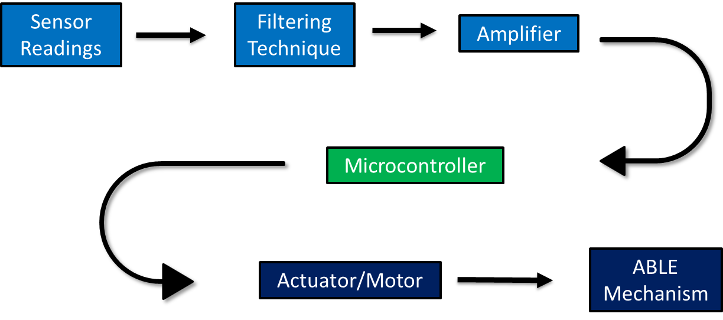

Figure : Schematic diagram of the overall A.B.L.E. system

## Preliminary Controller Design

Two different control methods are considered as possible candidates. One method is to assist the user with a pre-defined motion, where the assistance from the device is controlled by a fixed motion profile. The other method is to use an adaptive assistance, where the user’s intention is continuously measured and taken account in the controller.

### Position Controller

During the STS motion, the angle of the knee changes as the person stands up. Therefore, it is possible to obtain certain knee angle profile that is based on the time scale. In pre-defined motion method, the assistance is based on this angle profile. A desired knee angle profile based on either the operator’s preference or physio-therapeutic recommendation would be used as desired position values for a negative feedback position controller. The preliminary block diagram for this position controller is shown in Figure 31.

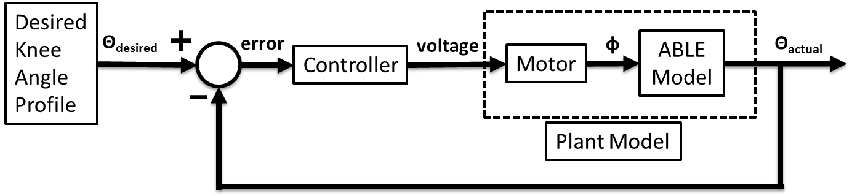

Figure : Position controller using knee angle profile as the reference signal

Once the operator’s intention to stand up is detected, a desired knee angle profile is fed into the controller as the reference signal. At this instance, the desired knee angle is compared with the current knee angle that the operator is at. Based on the error, the controller sends the corresponding voltage signals to the motor to increase or decrease its power. Then from the mechanics of A.B.L.E device, the operator would be provided with an assistive motion to fulfill the desired motion.

#### Pros and Cons

One of the most important advantages for this controller is that it is possible to help operators to achieve the proper and efficient STS form. Since the controller takes the knee angle as its desired position value, by feeding the knee angle profile of such proper STS motion as a reference signal, operators will most likely to complete proper STS motion. Another advantage for this controller is that it is a predictable system. Once the desired knee angle profile is configured to the controller, the operator would always get the same mode of assistance unless modifications are made on the settings. Therefore, the operator would easily predict the assistance and adapt to it without difficulties.

There are some drawbacks for this type of controller as well. The reference signal is fixed with a desired motion profile. Therefore the controller does not truly reflect the operator’s intention during the STS motion. Also from the fixed reference signal, the controller forces the operator to follow the motion to meet the desired knee angle profile whether the operator likes it or not.

### Torque Controller

The STS motion varies as one’s intention constantly changes based on time to time and different situations. Therefore it is crucial to take one’s intention into an account whenever the assistance is provided. One of the parameters that reflects one’s intention is his or her knee torque value. The amount of torque applied to the knee changes as the speed of STS motion changes, and the external loading condition such as lifting of heavy object, changes. Therefore in adaptive assistance method, a feedforward torque based controller is used to take account of this varying user’s intentions and the scheme is illustrated in Figure 32.

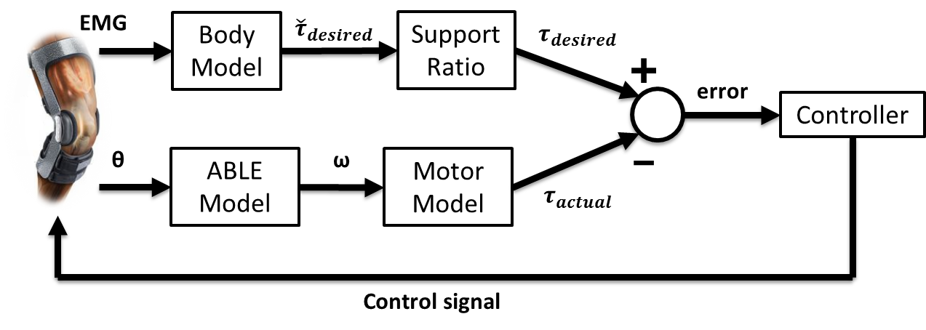

Figure : The system block diagram of torque based controller

It has been studied that the force exerted from the muscle groups can be estimated from the EMG signals [24]. Therefore, based on the EMG signals, it is able to calculate the desired knee torque that the user requires. This torque value is multiplied by the percentage constant, a support ratio, which determines the amount of assistance that the device provides to the operator. At the same time, current knee angles would be calculated from the encoders. Based on the physical model and the motor power consumption, the assistive torque value that the device is actually exerting at the instance can be calculated. The two torque values (desired and actual) are compared to each other, and the controller sends the control signals according to the errors.

#### Pros and Cons

Unlike the position controller, the reference signal is no longer fixed to the pre-defined values. The operator’s intention is continuously measured from the EMG signals and is converted to the torque values, which are reflected to the system to control the actual assistance. Therefore the operator would feel less of the resistive assistance compared to the position controller. In this sense, the torque controller is a low mechanical impedance controller.

However, since the controller takes more inputs and is involved with more complex calculations, it needs more computational power than the position controller.

### Controller Scheme Selection

Among many roles of the controller, the most important function is being able to capture the user’s intentions and reflect them to the device to provide the optimal assistance. The torque controller satisfies this role better than the position controller. Despite the complexity, the torque controller is chosen as the controller for this device.

## Estimating Torque from EMG signals

It is necessary to relate the EMG signals to the torque values to successfully utilize the torque controller. This relationship can be established through two approaches: physiological based approach and non-physiological based approach. The physiological approach yields more accurate relationship as it uses musculoskeletal model to estimate the muscle force and the joint torque. Common musculoskeletal model used in evaluating the EMG to muscle force is Hill-type muscle model. Hill-type muscle model is a mathematical model that predicts the muscle force by taking multiple inputs. These inputs include muscle activation level, muscle fiber length, tendon slack length, muscle isometric force, and etc. Based on these parameters, it is possible to closely approximate the amount of force the muscle exerts. However, it is also these parameters that make utilizing Hill-type model extremely difficult. These muscle parameters are subject based, and different for each person. In addition, the same subject can emit different body signals from day to day depending on the body condition and the equipment implementation set up. Therefore to achieve a satisfying approximation of the muscle force, it is necessary to measure and calibrate each parameters prior to using the device. [24, 34]

While physiological approach heavily focuses on the physical body model, non-physiological approach focuses on generating mathematical equations from a system identification perspective. In this approach, EMG signal is directly related to the torque value that is measured from simple experimental set ups. From numerous studies, it has been found that the relationship between the joint moment and the EMG signal in isometric contraction behaves linearly [35]. In addition, the net knee torque can be found from the summation of the torque values of the muscles from the extensor and the flexor groups. By combining the characteristics mentioned above, the following approximation of the knee torque can be derived.

C1 and C2 are the constant parameters that characterize the linear profile of EMG to torque relation. E1 and E2 represent the EMG signals from one of the muscle from the extensor and flexor group respectively. In this equation, it is assumed that each extensor and flexor group can be represented by one muscle.

Both C1 and C2 can be found using error optimizing studies. Firstly, known external force would be applied to the test subject while the subject tries to hold its position. This stimulates the equivalent knee torque that the subject exert at the knee. Then the error equation would be formulated between this value and the EMG value multiplied by the constant C. Using appropriate techniques, such as the least square method, the value of C that gives the minimum error would be calculated [36].

At this stage, it is concluded that physiological approach using Hill-type muscle model is rather a complex approach that is not feasible to be fully utilized with the current A.B.L.E. system set up. Although the approximation of torque is not as accurate as the physiological approach, the initial EMG to torque estimation will be conducted using non-physiological approach because it is simpler to implement and will promote easier debugging process.

## Choice of Hardware

Two of the most common microcontroller and microprocessors are compared as a potential controller: Arduino and Raspberry Pi. Arduino involves C and C++ as the programming languages while Raspeberry Pi involves Python. Even though Raspberry Pi are designed to handle higher level functions and has greater amount of storage space, Arduino is still capable of satisfying the requirements. With the previous experience on Arduino from some of the group members and knowledge of C++ programming, Arduino is chosen as the controller to work with. Among many different types of Arduino controllers, Arduino Uno is considered. There are cheaper and smaller Arduino boards than the Arduino Uno. However, the sampling rate of the smaller one is not as fast. Arduino Uno is one of the most commonly used microcontroller for the beginners. Even though Arduino Uno is one of the cheapest and smallest of its family, the clock (16MHZ) of the board is the same as that of the bigger members of the family. There are 6 analog inputs and 14 digital outputs on the board, which are sufficient enough for A.B.L.E. control scheme. Also, there are many standardized shields that are compatible with Arduino Uno, if more functionality is required. Therefore, Arduino Uno is selected as the microcontroller.

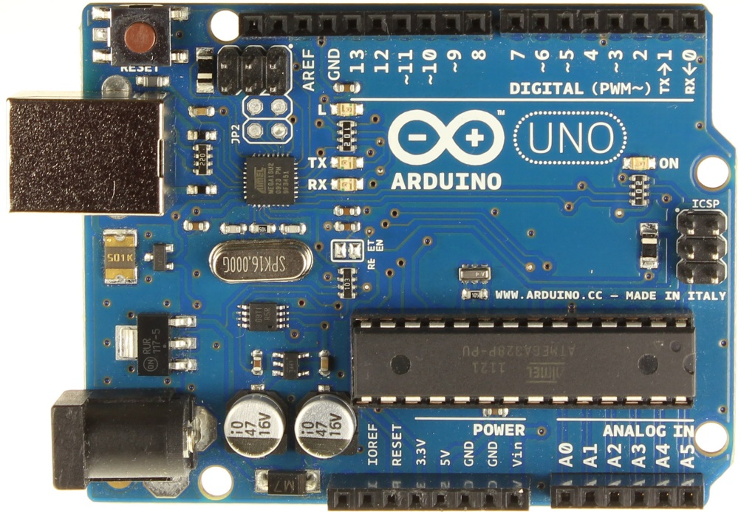

Figure : Image of Arduino Uno [32]

# Verification of Design – Signals and controls

## Engineering Calculation

EMG sensor is selected as the main sensor for detecting the initiation. This sensor is further analyzed to check if it meets the specifications of the project. The main engineering calculations used during this phase were to perform the filtering techniques on the EMG data. The filtering techniques included using a 4th order Butterworth High Pass and Low Pass filter, normalizing the EMG signal against the Maximum Voluntary Contraction (MVC), rectification, and removing the signal mean. The chosen sensor has different cut-off frequencies than what the research papers suggest for EMG to torque analysis. The real-time frequency data might require different frequency ranges. By analyzing the data in real-time with the hardware, and offline using the collected data, further refinement can be made. This will include determining the proper coefficients to be used in the software filtering technique. Another option is to build the Butterworth filter circuitry with the required frequency range. For the circuitry path, the proper value of the capacitors and resistors should be calculated. To validate the developed filtering techniques, real-time and offline analysis will be used.

Further refinement will be made to the controller by using the knowledge from EMG to torque profile from research. The two methods that are currently being considered are curve fitting optimization and parameter calibration. To verify the implementation of the controller, the knee brace with the actuator will be placed on dummy leg such a mannequin. Once the functionality and safety is verified, it will be tested on a human.

## Preliminary Testing

Preliminary testing involving the use of MATLAB to determine and verify the best muscle components to work with. Different filtering techniques are analyzed, and the filtering procedure for analyzing the EMG data is finalized.

Future testing will involve reading the EMG signals in real time. Firstly, the filtering techniques will be verified using the Arduino’s serial output. Once the filtering technique is confirmed, verification of the controller will also be done through Arduino’s serial output.

## Implementation Testing

Further testing will be done using the finalized controller and the sensors. The sensor would be connected to the controller using the computer as a dummy output. The purpose of the first testing is to determine if the hardware filtering is sufficient for this project and to verify that the sensor can detect the STS motion while rejecting other noise. In case the hardware filtering is not sufficient, the hardware can be modified or software filtering can be implemented. Once software filtering is implemented, it must be verified that it works in real-time and can strictly detect the STS motion.

The next stage of testing would involve replacing the dummy output with the chosen actuator. During this stage, various test scenarios will be conducted to verify the accuracy of the controller. Once the safety of the control scheme is verified, the whole system will be implemented with the knee brace installed on the user.

## Prototype

A preliminary prototype will be built to detect the initiation of the STS motion and to estimate the assistive torque.

## Determining User Interaction

The compatibility of the controller to the knee brace will be determined. This will include determining how much torque assistance the user requires, and the corresponding power the actuator needs to supply this torque.

# Mechanical Design

## Anatomy of STS in the Knee

Moving from sitting to standing or standing to sitting is a complex motion that involves the movement and contraction by many muscles throughout the body, from the neck to the ankles. In this project the knee is the only joint of interest. At the knee, leg extension is facilitated by four parts of the leg: the quadriceps muscles, the quadriceps tendon, the patella (knee cap), and the patellar tendon. There are four quadriceps muscles connected to the patella through the quadriceps tendon, and the tibia is attached to the patella by the patellar ligament. These components are shown in Figure 34 below. The movement is created by the quadriceps muscles contracting, pulling on the patella, which pulls on the tibia. The resulting force pushes the patella against the femur and straightens the leg. A free body diagram of the forces involved with straightening the leg are shown in Figure 35 below.

|  |  |
| --- | --- |
| C:\Users\jrarmita\Downloads\knee_anatomy12.jpg | C:\Users\jrarmita\Downloads\42c.jpg |
| Figure : Anatomical components of knee extension [37]. | Figure : Free body diagram of the knee during extension [38]. Fquad is the tension force from the quadriceps, Fpt is the tension force in the patellar tendon, and Fpf is the patellar femur force. |

The STS motions involve a similar mechanism and muscles since during sitting the same muscles exert forces as standing but are used to slow the descent of the body instead of lifting the body. In both movements the quadriceps muscles are the agonist muscles, meaning that they provide most of the force for the motion. Other muscles are involved as antagonist muscles, they act opposite to the movement and provide a stabilizing force. In both motions the hamstring muscles contract to control and the movement. Other muscles on the shin and calf stabilize the body and work with other joints for body control.

## Torque Requirements

The torque present in the knee was determined from Roebroeck’s study entitled, “*Biomechanics and muscular activity during sit-stand transfer”* [22]. In this study, ten healthy subjects were measured performing sit-to-stand transfers in a natural way. The starting position of the subjects was specified. Subjects were seated on a chair without a backing or armrests, and instructed to start with their trunk in a vertical position and with their hands on their hips. Subjects were then instructed to rise in a comfortable and natural manner until standing fully upright. A stick figure of a typical example of STS transfer is shown in Figure 36.

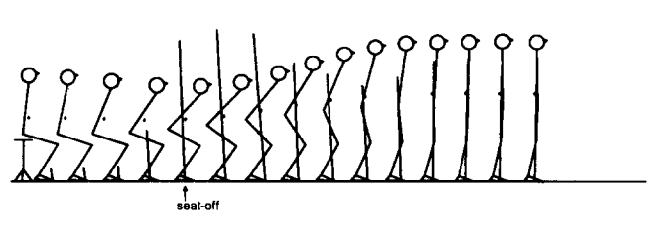

Figure : Example of typical sit-to-stand transfer. The time interval is 0.15s; the instant of seat-off is indicated [22].

The total time of the movement was 2.25 seconds on average, and seat-off occurred at 35% of the total movement time. Values of the net joint moments were calculated for *one* leg and normalized with respect to body weight multiplied by height (Nm∙kg-1∙m-1). The net moments about the hip, knee, and ankle joints are shown in Figure 37. The angular displacements of the hip, knee, and ankle joints are shown in Figure 38.

|  |  |
| --- | --- |
| Figure : Net moments about hip (solid line), knee (dashed line), and ankle (dotted line) joints [22]. | Figure : Angular displacements of hip (solid line), knee (dashed line), and ankle (dotted line) joints [22]. |

As shown in Figure 37, the maximum torque occurs at approximately 45% of the total movement time, and is determined to be 0.46 Nm∙kg-1∙m-1. This is a normalized value, and must be multiplied by weight and height to obtain a value for torque. Therefore, the weight and height of the 50th and 95th percentiles [39], for both males and females 65 years of age, are used. The resulting torque values are summarized in Table 5 below.

Table : Maximum torque about knee joint in males and females 65 years of age. The results are presented for the weight and height of the 50th and 95th percentiles for each gender.

|  |  |  |  |  |
| --- | --- | --- | --- | --- |
|  | **Male (65 Years)** | | **Female (65 Years)** | |
|  | **50th%** | **95th%** | **50th%** | **95th%** |
| **Weight (kg)** | 82 | 110 | 69 | 102 |
| **Height (m)** | 1.75 | 1.85 | 1.60 | 1.72 |
| **Torque (Nm)** | 66.01 | 93.61 | 50.78 | 80.70 |

As shown in Table 5, there is a large difference in the maximum torque values about the knee due to the deviation in height and weight between the values for the 50th and 95th percentiles. The values are also heavily dependent on gender. These torque values, in conjunction with the angular displacements of the joints (see Figure 38) are used for calculations later in the report.

## Free Body Diagram and Shear in the knee

Free body diagram (FBD) is used to evaluate the resultant shear force due to the induced torque at the knee. The diagram in Figure 39 shows the torque being applied at the knee joint. The FBD only shows the forces present due to the torque applied from the actuator and hence the weight of the body is neglected. The diagram in Figure 39 is split into two components as shown in Figure 40 ; FBD of the upper leg and FBD of the lower leg. In the FBDs, it is assumed that the lower leg is stationary and that it stays vertical to the ground at all times. In Figure 40 , F1 and F2 are results of the induced torque and R1 and R2 are reactional force on the knee joint.

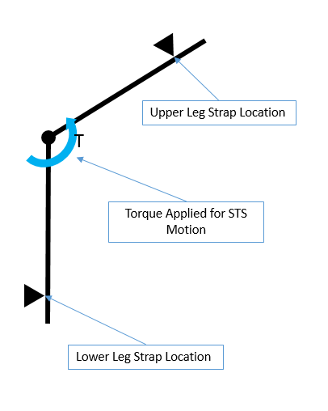

Figure : Torque applied at the knee joint from the actuator

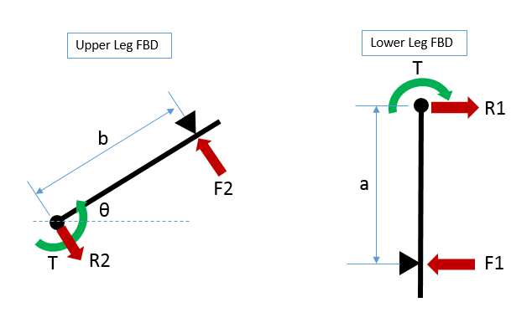

Figure : FBD of the upper and lower leg

Once all the forces are identified in the upper and lower leg, the resultant forces on the knee joint are identified as shown in Figure 41.

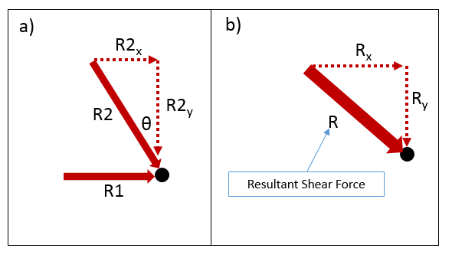

Figure : a) Reactional forces on the joints from the upper and lower leg b) Resultant shear force on the knee joint

There was a concern with the use of a powered brace because of the added shear in the knee could cause more damage. As shown above the brace does add an extra component of shear but a literature review by Escamilla, 2001 [40] shows that many studies have found that the shear forces naturally in the knee are much higher than any that the brace would apply and the results are shown in Table 6 below. It has been calculated that the shear force that the knee brace would apply is around 100N, much lower than the multiple hundreds seen to exist in the knee naturally. The cause for the shear in the knee can be seen by looking at the free body diagram, Figure 40 in the section above. The knee cap pushes against the femur and causes significant tibiofemoral shear force, the extra shear the brace adds is insignificant.

Table : Comparison of studies that quantified knee forces during a squat [40].

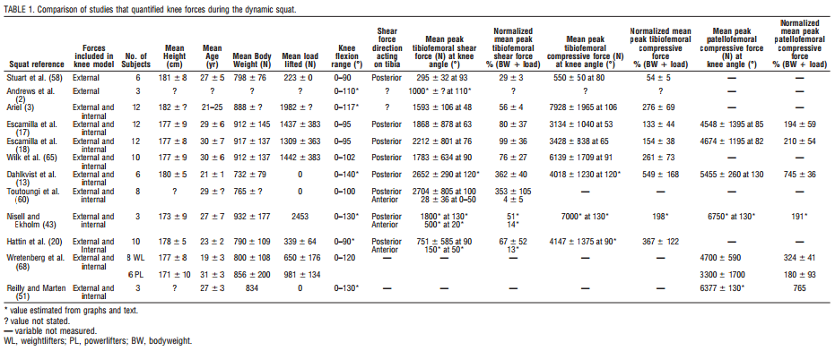

## Design Matrix

Design matrix is often used to lay out different options for different components of the design as shown in Figure 42 below.

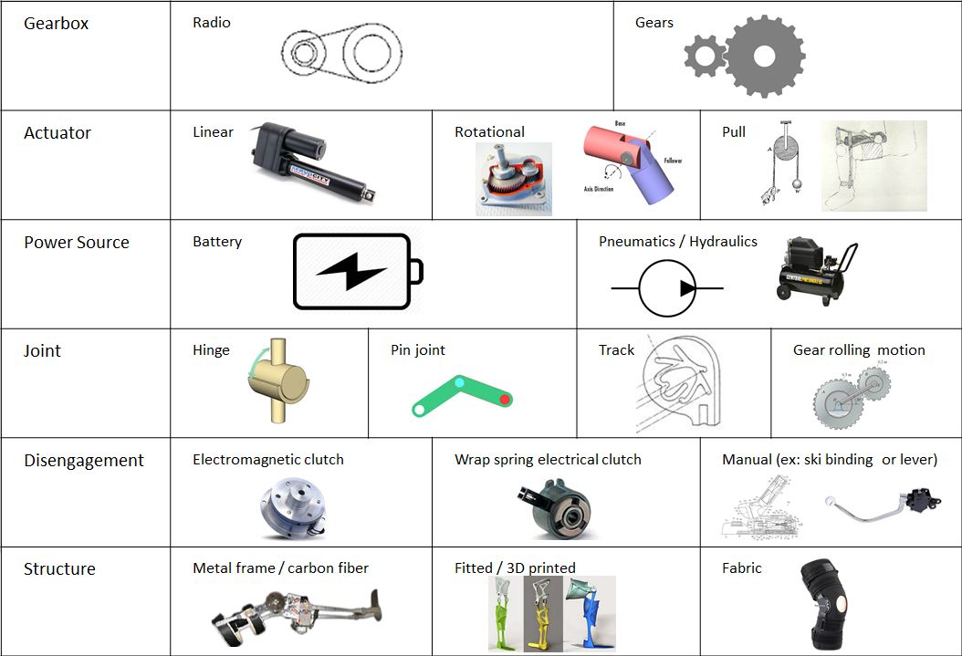

Figure : Mechanical design matrix

The left most column in the design matrix shows the key components of the design such as the gearbox, actuator, power source, joint, disengagement system, and structure of the brace. Conceptual designs can be configured by choosing each of the options for different components of the design.

## Concept 1: Linear Actuation

### Concept Generation

Based on the design matrix (see Figure 42), the key component that drives the mechanical design of the brace is the actuator. Once a suitable actuator is selected, the rest of the brace can be built around it. Concept 1 utilizes a linear actuator hinged at two points on the upper and lower portions of the leg, as shown in Figure 43.

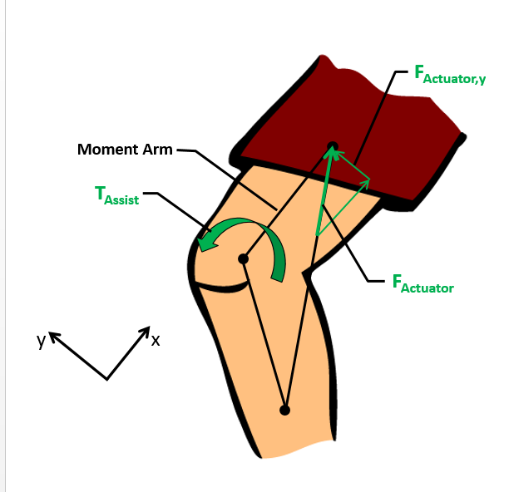

Figure : Force diagram of Concept 1: Linear Actuation.

As shown in Figure 43, the linear actuator imposes a force on the upper member of the brace which can be resolved into components. The useful force component, Factuator,y, acts perpendicular to the upper member of the brace (moment arm), and creates assistive torque about the knee joint. It is important to note that there are a variety of geometrical arrangements that could be used, and finding the optimal setup is one of the main design challenges of this concept. The required force of the actuator is dependent on a number of factors including the length of the upper member of the brace, the length of the lower member of the brace, and the overall length of the actuator itself (including the available stroke length). The extension speed is also a very important consideration. Since many of the linear actuators utilize DC motors, as the force the actuator must provide increases, the extension speed decreases. In order to achieve a cycle time of 4 seconds, as specified in the project requirements, a relatively fast extension speed is required. However, since the loads acting are the actuator are quite high, finding a suitable linear actuator is not an easy task and the component becomes more expensive. Calculations to approximate the forces that the linear actuator must be capable of providing are discussed in Section 6.5.2.

The next design consideration is the power source. Hydraulic or pneumatic powered cylinders are not feasible since a pump or compressor would be required. Therefore, electric power is selected for this concept, to be supplied from a battery. Calculations to approximate battery capacity and number of expected cycles are discussed in Section 6.5.2.

The next design consideration is the joint, or pivot point at the knee. One of the advantages of the linear actuator is that no gearing is required, which eliminates the need for gear rolling motion at the knee. However, the other joint components identified in the design matrix (see Figure 42) are all compatible with the linear actuation concept. Since linear actuation did not get past the conceptual stage, the optimal joint mechanism was never selected.

The next design consideration is the method by which the mechanical system disengages during non-STS motion to allow the user normal operation of their leg. The first two components listed in the design matrix, electromagnetic clutch and wrap spring electrical clutch, would have to be implemented at the motor level. Doing so would enable the controller to engage/disengage the motor. However, the screw (creates linear motion of the rod) in the linear actuator would need to back-drivable to allow for extension/retraction of the rod when the motor is not in operation. The ease with which the linear actuator can be back-driven is dependent on the type of screw (ACME screw versus ball screw), and the lead angle. While back-driving the linear actuator was considered as a possibility, it was ultimately rejected due to the resistive load it would impose on the user during non-STS motion. The third component listed in the design matrix, a manual disengage, was also explored. Mechanisms similar to those used in ski bindings were considered, as such a component would allow the user to disconnect the linear actuator from the brace. However, it was concluded that a manual disconnect did not adhere to the project objectives. The brace must detect user intention and automatically provide assistance. If the mechanical design of the brace requires the user to manually connect/disconnect the actuator, the user could just as easily press a button to initiate the assistive motion. Therefore, a unique slot mechanism was designed to allow the actuator to slide freely during non-STS motion. The slot mechanism can be seen in Figure 44.

The last design consideration is the structural members of the brace. Again, all three components listed in the design matrix are compatible with the linear actuation concept. Since linear actuation did not get past the conceptual stage, the optimal brace structure was never selected. Figure 44 below shows a conceptual rendition of the linear actuation concept.

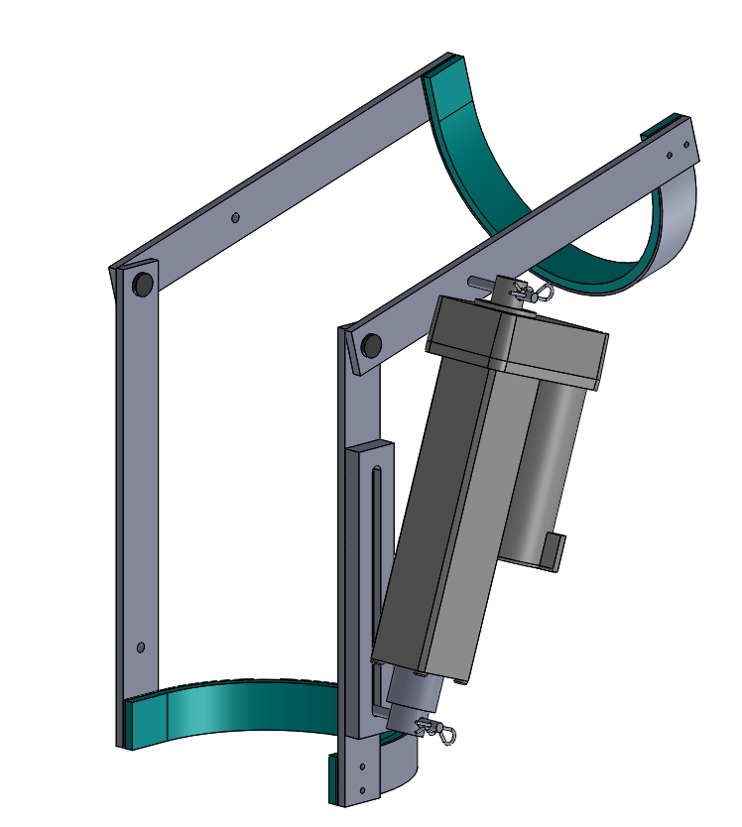

Figure : Conceptual rendition of Concept 1: Linear Actuation.

As shown in Figure 44, a simplistic metal frame with rigid structural supports is used for the conceptual rendition. A simple pin joint is used at the knee. Additional straps would be used to secure the brace to the user’s leg. The main areas of interest in Figure 44 are the linear actuator and the slot mechanism. The linear actuator shown in the model was selected based on the calculations performed in the following section. It is apparent that actuator is quite bulky. During STS motion, the actuator extends but does not slide since the downwards acting force locks it in place in the slot. After the STS motion is completed, the controller would retract the cylinder by a calculated amount to allow for free slide motion without interference.

### Concept Specifications and Calculations

To approximate the maximum force required from the linear actuator, the graphs shown in Figure 37 and Figure 38 are curve fit to obtain values for the knee torque (Nm∙kg-1∙m-1) versus time, knee angle versus time, and ankle angle versus time. To determine the *maximum* torque values, the *normalized* torque values obtained from Figure 37 are multiplied by the height and weight of a 65-year-old, 95th percentile, male (see Table 5). The maximum torque values are then multiplied by the following percentage assist values: 25%, 50%, 75%, and 100%. Assuming the length of the upper member of the brace to be a = 0.15m, and the length of the lower member of the brace to be b = 0.20m, and using the values for knee angle versus time, and ankle angle versus time, the force required from the linear actuator is calculated for each time step. Figure 45 shows the diagram used for the force calculations, the detailed calculations can be seen in Appendix A.

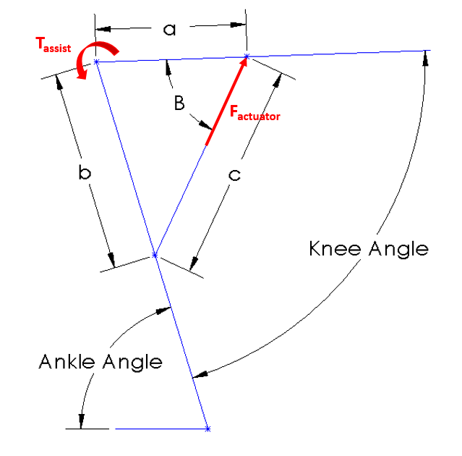

Figure : Diagram used for approximate force calculations.

The calculated maximum force values are listed in Table 7 below.

Table : Maximum required actuator force, based on 25%, 50%, 75%, and 100% assistance.

|  |  |  |  |
| --- | --- | --- | --- |
| Fmax, 25% Asst. (N) | Fmax, 50% Asst. (N) | Fmax, 75% Asst. (N) | Fmax, 100% Asst. (N) |
| 210.88 | 421.76 | 632.64 | 843.52 |

Based on the maximum forces listed in Table 7, and the approximate size requirements, different linear actuators were evaluated. Due to the high forces required to provide 75% and 100% assistance, the decision was made to provide torque assistance in the range of 25% to 50%, thereby reducing the maximum force requirement of the linear actuator. Lowering the maximum required force also reduces the size, weight, and cost of the linear actuator. The linear actuator selected for this concept is model number: TMD01-1906-4, or McMaster-Carr item number: 6530K111. Some of the key features of the actuator include, Acme screw driven, compact aluminum housing and outer tube, low current draw, double clevis mounting, easy to wire terminal strip, and permanent magnet motor. The technical specifications are summarized in Table 8 below.

Table : Technical specifications of linear actuator.

|  |  |  |  |
| --- | --- | --- | --- |
| Rated Load | 100 lbs | Voltage | 12 VDC |
| 444 N |
| Stroke Length | 4 in. | Current Draw  (@ Rated Load) | 7 A |
| 101 mm |
| Retracted Length | 6.75 in. | Speed  (@ Rated Load) | 0.7 in/s |
| 222 mm | 17.7 mm/s |
| Weight | 4 lbs | Duty Cycle  (@ Rated Load) | 25% |
| 1.8 kg |

As shown in Table 8, the linear actuator can provide sufficient force to meet the project requirements. The stroke and retracted lengths are also within an acceptable range for the geometry of the brace. Based on the voltage and current draw at rated load, the calculations (see Appendix A) show that approximately 135 cycles can be achieved using the capacity of the AlterG battery as a benchmark; this also meets the project requirements of a minimum of 30 cycles. Based on the conceptual model, the weight of the brace with the linear actuator is approximately 3.75 kg, which meets the project requirements of less than 4kg. It is important to highlight that the actuator alone weighs 1.8 kg, which makes it the heaviest of the options for actuation. The linear actuator is also quite bulky, refer to Figure 44 to see the relative size comparison with the structural frame of the brace. The linear actuator is also relatively expensive at a cost of $341.67 USD. This is essentially double the amount that was budgeted for actuation, making the concept less attractive. Lastly, based on the speed at rated load and the stroke length, the time required to reach full extension is 5.7 seconds. This does not meet the project requirements of a cycle time of less than 4 seconds. It is possible that a different actuator could provide faster extension speeds, however since this concept was not selected it was not explored further.

### Advantages

One of the main advantages of the linear actuation concept is the simplistic design. The design would be easy to manufacture, and would be at a lower risk of failure than the other two concepts since there are fewer and less complex components. Additionally, there are many similar designs available that provide good reference material to base the design off of.

### Disadvantages

Due to the asymmetric loading of the brace that occurs as a result of the actuator only exerting force on one side of the leg, there are moments created about all three axes. Only one of these moments is useful for generating assistive torque. The other two moments can cause the brace to twist, as well as impose damaging loads on the knee. The option of using two linear actuators (one on each side of the brace) was explored. However, the idea was rejected as it would increase size, weight, and cost of the brace.

Another disadvantage is that the linear actuator is not intended to handle non-axial loads. During operation of the brace, non-ideal loading scenarios could create moments about the extended shaft and significantly deteriorate the life of the component. This risk can be mitigated by using tracks to guide the rod, or rod ends that will only transfer axial loads to the actuator.

The last disadvantage identified is the potential for the linear actuator to interfere with the chair when the user sits down. Depending on the geometry selected, this could pose a major problem for the concept. To mitigate this problem, interference with the chair would have to be taken in consideration when evaluated the ideal geometrical configuration of the brace. Since linear actuation did not get past the conceptual stage, the optimal configuration was not determined.

## Concept 2: Rotational Actuation

### Concept Generation

The key differentiating factor of this concept is that it delivers torque directly at the knee joint by using a rotary actuator. Therefore unlike the linear actuation or the pull concept, the linear force does not have to be converted as torque.

As mentioned previously, hydraulic or pneumatic power source is not feasible. Therefore a standard DC motor is an ideal choice for this concept. In this concept, a gearbox is needed to amplify the torque from the motor since typical compact DC motors are not able to supply the required torque at the knee. The power requirements for the motor will be further discussed in the calculation section of this concept.

The next consideration of the design is the joint. For this concept, hinge joint, pin joint, and gear rolling motion are feasible. Hinge and pin joints are similar in a way that the two members in both of the joints share the same center of rotation. However, the two gears in the gear rolling motion have their own centers of rotation. The centers of the gears are connected with an arm which makes the rolling motion possible.

Disengagement of the actuation is necessary to reduce the resistance for the user when he or she is not using being assisted. Electromagnetic or the wrap spring clutch can be used to disengage the motor when it is not being used. However, there still remains the resistance from the gearbox. The most direct approach of removing all the resistance is to disengage the gear at the knee. Manual disengagement method is preferable because it would add less weight than an automatic lever.

The preliminary rotatory actuation concept is shown in Figure 46.

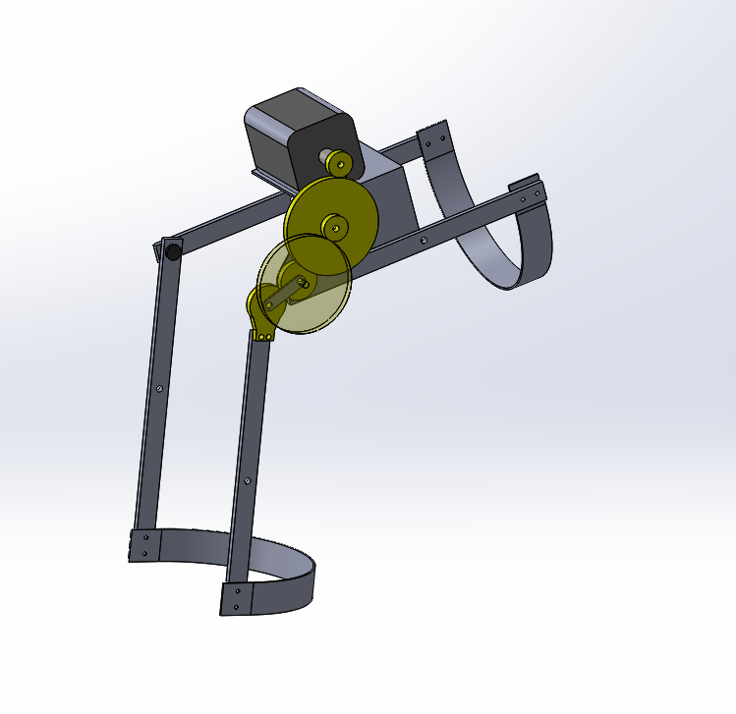

Figure : Rotary actuation concept

### Concept Specifications and Calculations

This concept delivers torque directly at the joint. Therefore only a gearbox ratio calculation is required for a simple pin joint to ensure that sufficient torque is applied at the knee joint. The necessary gear ratio is calculated by dividing the required torque value by the amount of torque that the motor supplies. The center of the gear rotation is not assumed to be at the center of the knee joint rotation in a gear rolling motion. As shown in Figure 47, when the size of the two gears at the joint are identical, the assistive knee joint torque is equals to the torque to applied to one of the gears. Assume that “Gear A” in is fixed and that “Gear B” is delivering the torque from the motor. The tangential force at the interface of the two gears equals to the torque at “Gear B” divided by the pitch circle radius, “L” of “Gear B”. Since the pitch circle radius of “Gear A” and “Gear B” are identical, the torque at center of the rotation of the arm is also equal to the torque delivered by “Gear B”.

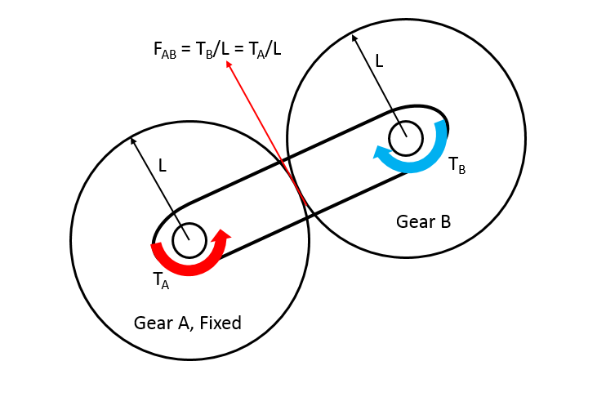

Figure : Torque transfer of gear rolling motion

As it can be seen in Table 5, the approximate required torque ranges from 25.39 Nm to 46.8 Nm, assuming that the device assists 50 percent of the required torque. Typical compact DC motors that are feasible for this concept supply 1Nm to 3 Nm of torque. Assuming the average required torque of 36Nm and a motor torque of 1.5Nm, the required gear ratio is 1:24. It is possible to use only one gear to achieve a gear ratio of 24 but this will result in using a very large gear. Therefore a compound gear train can be used which is shown in Figure 48**.** The advantage of using this gear train is that greater gear ratio can be obtained in less space with fewer dynamic problems.[41] Two sets of gear ratios of 5 can be used to achieve an overall gear ratio of 25.

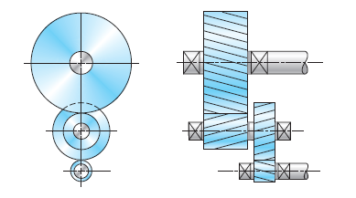

Figure : Two stage compound gear train [41]

### Advantages

The gears can easily be enclosed in this concept. Therefore potential pinch points can be removed and the concept would be more aesthetically pleasing.

The amount of space that this concept requires on the side of the leg can be minimized by placing the motor on top of the thigh. The gearbox still has to be placed on the side of the leg but since the transferred torque is quite low (approximately 35Nm maximum), the thickness of the gearbox can be relatively small.

### Disadvantages

Manufacturing of the gearbox is complex. The two stage compound gearbox contains several gears which all require its own bearings. In addition, thrust bearings are required if helix gears are decided to be used.

As mentioned in the disadvantage section of the linear actuation concept, the rotary concept also applies torque asymmetrically. Additional torsional force can cause unwanted torsional bending of the brace or even apply torsion on the user’s knee.

## Concept 3: Pulling Actuation

### Concept generation

The idea behind the third concept is to pull instead of push. In this design the assistive torque would be provided by pulling the end of linkage sticking out off of the end of the leg. The section sticking out acts as a moment arm and the cable pulls on it to generate the torque in the joint of the brace. One of the first sketches used to explain the concept is shown in Figure 49 below. As this sketch shows the motor is mounted on the top of the leg and spools, in this case, two cables.

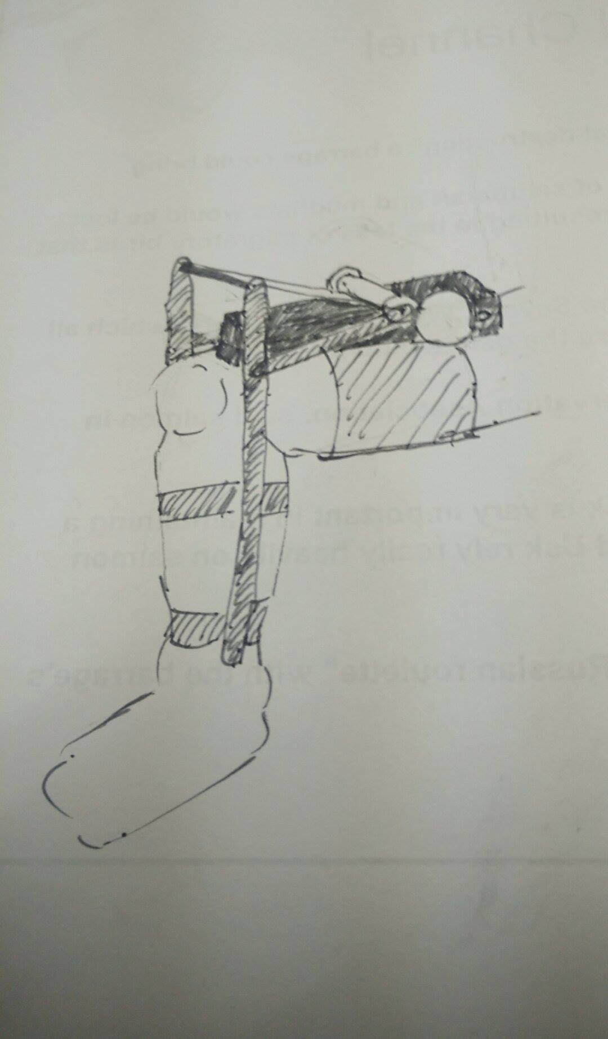

Figure : Preliminary sketch of pulling actuation concept. Leg is drawn with attached frame and straps (striped), motor (black box), spool, and cables.

A second iteration of the design is performed in order to determine a better shape. In this design the four membered structure with two members on either side of the leg, and two string is broken down into a two member design on the front center of the leg, this design is shown in Figure 50 and Figure 51 below. The goal of this design was to minimize weight with half the number of components in the structure, remove the complexity of having two strings, and so that all of the hard components could be only on the top of the leg. The major problem with this design is the joint. The complexity added by having a brace joint that is not in the same location as the knee joint is undesirable. For this reason a further iteration was performed. This concept has been chosen as the actuator for the preliminary design, as discussed in section 6.8 below, and more information about the brace design is shown in section 6.9 below.

|  |  |
| --- | --- |
| Figure : Initial concept generation | Figure : SolidWorks model of initial design |

### Concept Specifications and Calculations

This is the concept chosen for the preliminary design, as shown in section 6.8, the specifications and calculations will be discussed in section 6.9 below.

### Advantages

There are significant advantages to using this design over the other two. The first advantage is that because of the moment arm, the amount of torque that needs to be provided by the motor is much smaller, this is shown in the calculations in section 6.9 below. This allows for a smaller motor or higher possible assistance. From a smaller motor follows s smaller battery, and less overall weight. The design also allows for more flexibility in the structural design as far as how many structural members and where they are placed. It is possible to not have any hard components on the side or back of the leg. It also helps comfort because the movement of the brace is in line with the natural movement of the leg. The loading is symmetrical and there are no toques acting on other axes that could harm the user. The final advantage is that it is different from other designs. Since there are other commercially available knee braces, and research projects use mostly linear and rotational actuation it is nice to do something unique.

### Disadvantages

There are also disadvantages to using this design. The first disadvantage is that there is a possible decrease in the precision of the force application since a cable can stretch and can easily become slack and stop providing force. There are some safety issues with fairly large tension in the cable that is lining the leg and could injure the user if it were to snap. Finally while it is nice to do something different, it also means that there is little to no information to guide the design or be able to see what has worked in the past.

## Decision Matrix

To evaluate the different design concepts a decision matrix was used, shown in Table 9 below.

Table : Decision Matrix of the Mechanical Design Concepts

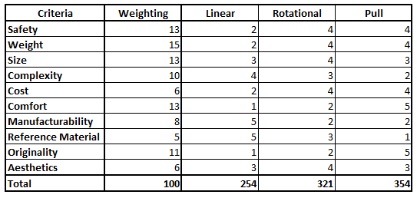

As shown the criteria identified to evaluate the designs are safety, weight, size, complexity, cost, comfort, manufacturability, the availability of reference material, originality, and aesthetics. Weightings are applied to each category as deemed suitable by the team. The design matrix was completed multiple times by each member in the design group, before averaging the values and then coming to a consensus on what the values for weighting and for each design should be. In every iteration, linear actuation scored the lowest and was discarded. Concepts 2 and 3 were very close to each other, less than a 5% difference in the scores in initial iterations. However after exploring the pull actuation and working through some concerns, the decision matrix was performed and the pull actuation was clearly the best decision, 10% better than rotational and 26% better than linear.

## Preliminary Mechanical Design

### Design overview

The preliminary mechanical design for the brace is shown in Figure 52 and Figure 53 below. The dimensions used are rough approximations based on looking at legs of group members. The ball and stick model of the leg is also a realistic size to show scale.

|  |  |
| --- | --- |
| C:\Users\jrarmita\Downloads\12319403_10156540559700508_1600776911_n.jpg | C:\Users\jrarmita\Downloads\12336096_10156540563155508_1207387248_n.jpg |
| Figure : Preliminary design of the brace in seated position. | Figure : Preliminary design of the brace in standing position. |

#### Structure

The basic structure of the brace is dictated by the choice of the actuator. The basic shape of the brace must have structural members along the upper and lower legs, one of the structural members must have a moment arm that can be pulled on to create torque about the brace joint. There have been many design considerations that have gone into the design of the brace structure.

In this design the moment arm sticks out vertically. The alternative would be to have the moment arm stick out horizontally from the front of the knee, as shown in Figure 54, but this was not done for simplicity. It is better to place the motor as high as possible on the thigh in order to reduce the pendulum effect of the heavy motor swinging. In order to pull a horizontal moment arm from the shin, and have a motor on the thigh, the cable would have to be much longer and follow a more complicated path.

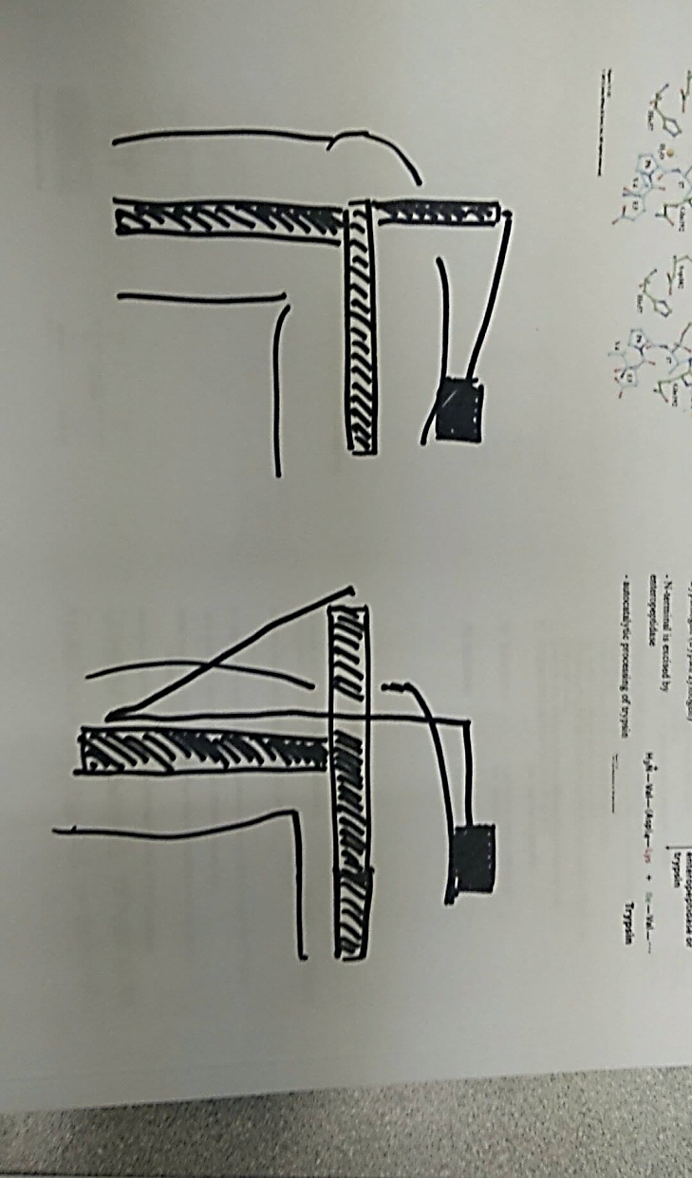

Figure : Moment arm orientations.

The structure was chosen to use three members so that there is only one cable, and the brace joint overlaps with the knee joint. Having one cable is a benefit because of reduced complexity. Trying to make sure that both cables are wound simultaneously, and symmetrically is unnecessary. Two members are used on the lower legs so that the brace joint and the knee joint overlap, allowing for an easier brace joint design. This design also has the benefit of lowering the joint allowing for a longer moment arm.

The horn comes out off of the front of the shin to leave clearance for the leg when standing. It comes into a horn so that it is centered but the reason why it is shaped as a horn and not an arc or rectangular is only for looks. The brace and knee are able to fit within the horn and there is no interference when the leg is straightened.

|  |  |
| --- | --- |
| C:\Users\jrarmita\Downloads\12312276_10156540590820508_546021273_n.jpg | C:\Users\jrarmita\Downloads\12351033_10156540591645508_873387982_n.jpg |
| Figure : Magnified view of the knee joint of the preliminary design of the brace [front]. | Figure : Magnified view of the knee joint of the preliminary design of the brace [side]. |

#### Attaching the Motor, Controller, and Battery

The motor and controller locations are not yet fixed however they should be as high as possible on the leg, especially the motor which is the heaviest component. When the weight is lower on the leg it acts as a pendulum when walking and is very uncomfortable. The motor and most like the controller will be attached to the structural member along the top of the leg. The motor must be well fixed since it needs to stay in place to pull the cable. There also cannot be the possibility of it being torn off. The spool will also have to be properly fixed so that the motor only has to provide torque and not be subjected to any forces pulling on it.

The battery location is undecided. It will depend on the required size, and that will depend on the size of the motor, and number of cycles that are to be provided. If it is small enough it could be placed near the motor and controller on the top member. If it is too large brace dimensions could change in order to decrease motor size. An alternative consideration is to place the battery on a belt on the hip.

#### Attaching the Brace to the Body

In order to attach the brace to the body the initial design is to use straps on the upper and lower leg. Straps are more comfortable than hard material such as plastic, and since the brace only needs to pull on the upper leg fabric straps are appropriate. There will also have to be a method to place the electrodes, sensors and connect them to the controller but that will be determined at a later time.

#### Disconnect When Not In Use

A concern of the design was how the brace would operate when not being used to sit or stand. This design allows for an easy method to “disconnect” the brace when it is not in use, to put slack into the cable. Without any tension in the cable there will be no resistance to movement and the brace will be able to be worn when not in use.

#### Joint

The joint in this preliminary design is simply a pin joint. There are multiple variations of the joint that have been covered above and it is yet to be determined which one will be used. It should be noted that the results of Regalbuto et al., 1989 [42] found little difference in the forces in the knee between different joint designs, however they tested different brace joints that were more representative of the actual knee joint. It is more important that the joint is more complex than a pin joint, but the difference between the more complex joints is minimal. The joint for this design must be able to withstand high shear forces applied by the cable. Possible joint designs have been made by Walker et al., 1985 [43], Pratt et al., 1987 [44], as well as those tested by Reagalbuto et al, 1989 [42].

### Calculations

#### Motor Torque

Figure 57 and Figure 58 below are free body diagrams of the brace focusing on the tension in the cable.

|  |  |
| --- | --- |
| C:\Users\jrarmita\Downloads\12343194_926499797442967_1077077466_o.jpg | C:\Users\jrarmita\Downloads\12343194_926499797442967_1077077466_o.jpg |
| Figure : Free body diagram of brace in seated position. | Figure : Free body diagram of brace at an arbitrary angle. |

The following calculations are used to calculate the angle B.

$$Y=Y_{2}-Y_{3}-\left(Y_{1}\cos{A}+X_{1}\sin{A}\right)$$

$$X=X_{2}+\left(X_{1}\cos{A}-Y_{1}\sin{A}\right)$$

$$C=\tan^{-1}\left(\frac{Y}{X}\right)$$

$$B=A+C$$

The brace torque (BT) is calculated as the percent of the knee torque (KT) (see section 6.2 above) that is being assisted (% assistance)

$$BT=KT*\%Assistance$$

The brace torque can also be calculated by the amount of tension in the string, the following is used to solve for the tension in the string.

$$BT=X_{1}F_{y}+Y_{1}F_{x}$$

$$BT=X_{1}T\sin{B}+Y_{1}T\cos{B}$$

$$T=\frac{BT}{X_{1}\sin{B}+Y_{1}\cos{B}}$$

The motor torque (MT) can be calculated the tension in the string multiplied by the radius of the spool (r).

$$MT=T*r$$

Using approximated dimensions similar to those in the brace in Figure 52 and Figure 53 above, a 99th percentile male, with 50% assistance the maximum motor torque calculated is 3Nm and the maximum tension in the rope is 335N. These numbers will certainly change once brace dimensions are chosen. The results of the calculation for the motion from sitting to standing (knee angle from -15⁰ to 85⁰) is shown in Appendix A.

#### Reaction Forces on the Body

The reaction forces on the body will be very similar to what those present in all knee braces, and should not cause any harm, as shown in Section 6.2.

#### Sizing the Motor

The motor that will be used will most likely be a geared DC motor. The dimensions of the brace have an effect on the amount of power that the motor will need to provide, but based on reasonable dimensions, and for a 95 percentile male (weight and height), and providing 50% assistance the motor torque will be around 3Nm. This a very reasonable value of torque for a geared DC motor to reach. The benefit is also that the motor can be smaller, more efficient, and will most likely require a reasonably sized battery.

The motor will most likely be a right angle DC motor so that the motor can be placed parallel to the length of the leg. Another option is to attach a right angle gearbox, which is essentially a premade, enclosed bevel gear to the motor and achieve the same result with two components. The amount of torque needed is low enough that there is a lot of flexibility for the motor selection.

### Looking Towards the Final Design

#### Finalize Design

The design presented above still has more considerations to cover. How are the motor and controller going to be mounted on the upper leg member? How are the straps going to be tightened? What kind joint will be used? Will the straps interfere with reading the EMG signal? Is the motor precise enough, is it compatible with the controller? How will the cable act when it has slack, will it need to be in a sleeve, and should a spring be used to minimize the slack? More issues that will come up once the design starts to become more finalized and even more unforeseen issues will certainly come up during testing.

The final components will need to be selected. An appropriate motor will need to be selected, structural member thickness and size, material selection, choosing fabric for the straps, battery sizing and many more.

#### Finalize dimensions

The dimensions currently used to visualize the design in Figure 52 and Figure 53 above, are the same as those used in the calculations in Appendix A below and are rough approximations. There will need to be more investigation into ideal dimensions to maximize torque and determining what fits best onto the body. There will also have to be a determination of how to fit the many sizes of bodies and whether that is by making the design very customizable and flexible to different body shapes, or determine that there will need to be different size braces (small, medium, large) and have body constraints for each size of brace. For the prototype specific dimensions may be tailored to the group member who will be doing most of the testing.

The dimensions must also consider the convenience of use. There will need to be locations designated for EMG electrode placement, ensuring that the structure does not interfere with the signal detection and the electrodes can be connected conveniently. The dimensions and design will also need to consider how the brace is put on and removed, the location of buttons and devices to interact with the device, and the possible need for a quick release in the case of an emergency.

#### Fabrication and Testing

According to the schedule the final design is expected to be completed by the third week of the term. This will then leave most of the term for fabrication, testing, and improving.

# Verification of Design – Mechanical

### Engineering calculation

#### Force Analysis

The design team must check the reactional forces on the user from the brace actuation force. Checking the reactional forces is paramount since unwanted reactional forces can harm the user. The reactional forces will be predicted using the free body diagrams. In addition, basic force analysis of the structures will be conducted to check for potential mechanical failures.

#### Gearbox and Pulley Ratio

A more in-depth calculation will be conducted to find the optimal pulley and gearbox ratio. The gearbox ratio and the pulley sizes will be chosen based on the output performance, weight, and size.

### Finite Element Analysis

Finite Element Analysis (FEA) is a useful engineering analysis in determining the stress distribution in a given structure. Bending and moment diagrams can be useful in predicting maximum stress points in simple beams. However simple engineering diagrams become unfeasible for predicting high stress points in complex structures. FEA computer software programs are powerful tools that can be used to predict high stress points and to visualize the stress distribution within a structure. In the case of the brace design, FEA will be used verify that the designed structures can withstand the applied loading and to decide if structural reinforcements are required in certain areas of the design.

### Prototype

Prototypes are often used as a proof of concept to check that the actual design satisfies the intended function. In the preliminary verification, a simple prototype of the brace should be built to verify that the actuation method moves the joints as intended. So far in the project, all of the conceptual designs of the actuation systems have been on paper. Therefore the joint movements due to the actuation system are only predicted and not verified. The physical prototype would not only be a sanity check but it would also provide the designers with a physical sense of the design.

### Determining User Interaction

#### Brace Installation

The method of installation of the preliminary leg brace must be evaluated for user friendliness. The designers must determine how the user will install the brace and optimize the brace design in such a way for the user to mount the brace as conveniently as possible. The brace should also be easy to remove.

#### Controllers

In the preliminary design of the brace, the specific layout of different controllers and switches may not be accounted for as the preliminary design is used mainly to design the actuation system, joints, and the main structural members. The designers must determine all the switches and controllers the user would interact with and find optimal locations of the controllers for the next phase of the design.

#### Emergency

In the case of an emergency, there must be a way for the user to quickly remove the mechanical brace. In the preliminary verification, the mechanical designers will determine how quickly the current design can be removed. In addition, the design will be iterated to optimize the process of removing the brace.

#### Miscellaneous

It is important to determine all the ways that the user can interact with the brace. Finding more ways the user can interact with the brace results in more a thought out and user friendly product. Miscellaneous items include how the user will recharge the battery, maintain the brace, and calibrate the settings.

### Design for Manufacturing and Assembly

#### Part Procurement

In order to minimize the research and development time and the complexity of manufacturing the brace, it is advantageous to use as many off-the-shelf items as possible in the design. Once the preliminary design is complete, the designers should review the design to determine which parts can be procured off-the-shelf. The parts that cannot be purchased as commodities, must be custom made. Then it must be decided which parts will be machined in house or sent to an outside vendor. For example, a simple bracket may be machined by one of the teammates but more complex shapes that require experience or high precision may need to be sourced from a vendor.

#### Parts Assembly

During the preliminary verification, the designers must check how the individual parts will assemble together. Many times, the way the parts assemble in a CAD program seems viable. However once the designers think through the assembly process order, they may find problems such as not having enough access to screw a bolt or not having enough space to fit a part through a gap. Therefore it is also important that the product is designed so that the assembly process is feasible. In addition, small details such as wire routing must also be considered during the preliminary design verification.

### Preliminary Digital Buyoff

#### Checking for Missing Components

Digital buyoff is used to check for deficiencies of the digital model of the product. This verification can serve as a final check of the preliminary design. The more detailed and updated the digital model is, the more items that can be verified. This process is effective in finding deficiencies such as missing components because visual check is often useful in finding things that have not been considered.

#### Checking for Remaining Safety Hazards

The digital model is also useful in finding safety hazards that have not been found. In this verification step, the team will check the digital model against the list of the safety hazards that have been considered. In addition, the team will attempt to find potential safety hazards that have not been discovered previously. Finally, the approximate weight of the product will be checked using a Computer Aided Design (CAD) program and product data sheets for off-the-shelf components.

# Design of Safety and Sustainability

## Safety

### Mechanical/Electrical

#### Mechanical Failure of the Parts

Sudden mechanical failure of the parts can harm the user significantly. For example, if the structural member of the brace fractures while the user is standing up, the user can fall back to the chair or even fall sideways if the brace is used only on one knee. Thorough force analysis and FEA should be conducted with adequate safety factors to prevent sudden mechanical failure of the parts.

#### Pinching Hazards

The most prominent pinching hazard is at the joint area. Without proper guarding, the user’s fingers can get caught in the joint area while the brace is in motion.

#### Burn Hazard

The battery or the motor can heat up excessively and can potentially burn the user. Therefore it is important to insulate the battery and the motor in such a way that the user’s skin does not directly contact the motor or the battery.

#### Exposed Wires

Improperly routed wires can get caught in the joint area and be exposed or cut. The exposed wires can lead to electrocution or shorting of the circuit which can result in a loss of function or electrical fire. In order to mitigate the electrocution or the shorting of the circuit, all of the wires must be insulated and routed properly.

#### Poor Ergonomic Fit

Proper fit of the brace is important to support the user effectively during the sit-to-stand motion and to avoid harming the user. Poor ergonomic fit can harm the user if the joint center and the assumed center of rotation of the knee is not aligned. In addition, if the brace is excessively tight, it can cause the user pain and restrict the blood flow in their leg.  Detailed design will need to be tailored or be size specific to the individual user to ensure proper fit.

### Signal/ Control

#### Intention Detection Failure

Two different scenarios of intention detection failure can occur.  First, the controller can fail to detect the intention when the user is attempting to stand.  This can prevent the user from standing up due to the absence of support and additional weight of the brace. On the other hand, the controller can falsely detect the intention while the user is seated.  To mitigate these scenarios, thorough testing should be conducted to determine the EMG signal range of the STS motion.

#### Over-Extension or Flexion of the Joint

While the user standing up, there is a possibility that the motor can overdrive and lead to an over-extension of the knee. This can potentially harm the knee joint of the user. To mitigate over-extension of the knee, there needs to be an upper limit set on the motor. This upper limit can be a mechanical hard stop and/or a software stop code.

#### Sudden Torque Increase

If there is an abrupt increase in the motor torque during STS, the user can be destabilized and fall. To avoid such a scenario, there should be a fixed limit on the amount of sudden torque change allowed during the STS motion. The nature of the torque detection method can cause sudden torque increases. However testing should be done to recognize torque increase anomalies and the code should be written to ignore high torque request.

## Sustainability

When designing a product, it is important to consider sustainability. Sustainability does not only consider the recyclability of the material used but also how that material is manufactured. For example, some materials require less energy and produce less pollution to be manufactured than other materials. Therefore in order to account for sustainability, the entire manufacturing cycle of a product must be examined.

The team will address sustainability by maximizing the use of recyclable materials in the design of the A.B.L.E. device.  The team must consider the abundance of the material used, not only because of cost, but also to not contribute to the depletion of a rare material. In addition, the team must consider the entire manufacturing cycle to choose a material that is the most environmentally friendly. When designing the A.B.L.E. device, it is important to design for the eventuality of component failure. More specifically, the individual parts should easily be replaceable so that when a part fails, the entire product does not have to be replaced.  This will not only reduce the maintenance cost for the customers but will also aid in reducing unnecessary waste.

# Design Project Management

## Project Objective and Deliverables

The project objective is to design an assistive biomechanical device to aid the user in a Sit-to-Stand (STS) motion. The device must accurately detect the user’s intention to stand, and actuate the mechanical system to provide assistance. An emphasis will be placed on safety, as the device cannot harm the user. The two *main* key performance indicators (KPI’s) are as follows. (1) The ability to detect user intention must be greater than 95%, and will be verified through extensive testing. (2) The brace must be capable of providing torque assistance in the range of 25% to 50%, and will be verified by taking measurements on the prototype. The other KPI’s, as well as the status of the functional, non-functional, and constraint requirements of the device can be seen in the Project Requirements (Revision 005) in Appendix A.

The deliverables for ME 481 can be seen in Table 10. All deliverables defined for ME 481 have been completed.

Table : Deliverables for ME 481

|  |  |  |
| --- | --- | --- |
| **Deliverable** | **Deadline** | **Status** |
| Proposal Review Meeting | October 9th, 2015 | Complete |
| Design Proposal Report | October 14th, 2015 | Complete |
| Develop preliminary concepts for mechanical design of knee brace | November 2nd, 2015 | Complete |
| Design Project Review 1 | November 6th, 2015 | Complete |
| Establish signal detection/processing method | November 22nd, 2015 | Complete |
| Determine initial controller approach | November 22nd, 2015 | Complete |
| Select concept for mechanical design of knee brace | November 22nd, 2015 | Complete |
| Design Project Examination 1 | November 27th, 2015 | Complete |
| Develop preliminary design of knee brace | December 2nd, 2015 | Complete |
| Design Project Report 1 | December 4th, 2015 | Complete |

The deliverables for ME 482 can be seen in Table 11. The deliverables and their corresponding deadlines are rough approximations, and will be refined at the start of the winter semester.

Table : Deliverables for ME 482.

|  |  |  |
| --- | --- | --- |
| **Deliverable** | **Deadline (End of Week)** | **Status** |
| Design Project Review 2 | Week 2 | Incomplete |
| Finalize detailed mechanical design | Week 3 | Incomplete |
| Establish EMG to torque profile | Week 3 | Incomplete |
| Establish detailed control scheme | Week 3 | Incomplete |
| Mechanical design components in-hand | Week 4 | Incomplete |
| Fabricate mechanical prototype | Week 6 | Incomplete |
| Fabricate signal processing prototype | Week 6 | Incomplete |
| Design Project Examination 2 | Week 6 | Incomplete |
| Integrate mechanical/signal processing prototypes | Week 8 | Incomplete |
| Design Project Review 3 | Week 9 | Incomplete |
| Integrated prototype, ready for testing/debugging | Week 10/11 | Incomplete |
| Design Project Examination 3 | Week 11 | Incomplete |
| Fully integrated, working prototype | Week 12 | Incomplete |
| Project Exposition | Week 12 | Incomplete |
| Design Project Report 2 | Week 13 | Incomplete |

## Work Budget

The actual hours worked versus planned hours can be seen in the Schedule and Work Breakdown Structure (Revision 006) in Appendix B. At the beginning of the term, the team did a good job at meeting the planned hours. However, in weeks 6 and 7, the actual hours worked fell below the planned hours. This was due to increased workloads in other courses, and midterms. In weeks 8 and 9, the team met the planned hours of work. In weeks 10, 11, and 12 the team exceeded the planned hours of work. Week 12 in particular saw a significant increase in actual hours worked. There are two main reasons for this increase. The first reason is the fact that the team had to make up for the hours lost during weeks 6 and 7. The second reason is that the planned hours (especially in weeks 11 and 12) were simply not enough to complete the amount of work there was to do. Despite budgeting 9 hours per week per team member, it was quickly realized that there was insufficient working capacity without exceeding the planned hours. As a result, the total actual hours worked during ME 481 was approximately 17% higher than the planned hours. This is concluded to be acceptable, since a 20% buffer was added between the planned working hours and the team capacity at the beginning of the term when the schedule was created.

## Schedule

Refer to the Schedule & Work Breakdown Structure (Revision 006) in Appendix B. The main deliverables are summarized in Section 9.1. The schedule for ME 482 has been revised to better represent the work that needs to be done. One of the main differences in the new revision is that the planned hours exceed the team capacity at certain points throughout the term to match the heavy volume of projected work. To counter this, the planned hours for certain weeks are well below the team capacity to balance the workload and maintain a 20% buffer between planned hours and team capacity. The schedule will be continuously monitored and updated throughout ME 482, and if the need becomes apparent, the buffer can be reduced to allocate more hours towards completing urgent tasks/deadlines.

## Budget

Refer to the Financial Budget (Revision 005) in Appendix B for a full breakdown of the current project budget. The team has $900.00 in available school funding. Applying a 20% contingency to this amount gives $180.00 in emergency funds, and puts the available budget for the project at $720.00. The current sum of the prototype material costs is $697.75, which leaves $22.25 in remaining funds. There have been no actual expenditures to date, however the signal processing team is planning to buy one of the muscle sensors to test for suitability over the break. It is important to note that while fairly accurate costs have been identified for the signal processing equipment, the prototype material costs for the mechanical design are still rough approximations. Pending approval of the preliminary concept, the detailed mechanical design (to be completed in the first two weeks of ME 482) will give a much clearer indication of the actual costs. In the event that the cost of the prototype materials for the mechanical design exceeds the approximations, there are two possible methods for increasing the project budget. The first, and preferred, method is to apply for the ‘Canadian Posture and Seating Centre Award for Project Funding’ at the beginning of the winter term. The fund was established to facilitate the development of assistive devices for physically disadvantaged persons, and awards are normally valued at between $500 and $2000. The deadline to apply is February 15th, which allows sufficient time to establish whether or not the extra funding is needed. The alternative method to increase the project budget is monetary contributions from each team member. This method is not ideal, and will only be used as a last resort.

## Risk and Mitigation Plan

Refer to the Risk Register (Revision 002) in Appendix B for a full breakdown of the risks identified for the project, and the mitigation plans in place. The first risk is signal detection failure, which refers to the inability to develop a reliable intention detection system. The mitigation plan specified at the beginning of the term was to start testing early, and to draw on advice from others who are more knowledgeable in the field. Thus far, the signal processing team has done a good job of testing the various available signal processing equipment, and a preliminary controller design has been created. The team is on track and the risk level is under control. The second risk is expensive components, since the cost of the prototype materials for the signal processing and mechanical design can be quite high. The mitigation plan specified at the beginning of the term was to apply for funding (if deemed necessary), and to make use of available equipment. Thus far, the signal processing team has made use of equipment provided by the team’s Faculty Advisor, James Tung, to run various tests and collect data. The signal processing team has also specified the prototype components needed and their actual costs, and it is within the allotted budget. The mechanical design team is still in the process of selecting the prototype components, and only rough approximations are available for the costs. However, the preliminary research shows that the prototype materials for the mechanical design will be within the allotted budget. The third risk is insufficient knowledge, which refers to a lack of knowledge in any of the major areas including kinesiology of the knee and signal processing. The mitigation plan specified at the beginning of the term was to conduct in depth research, and to acquire knowledge from others more knowledgeable in the field. Thus far, the team has done a satisfactory job at expanding knowledge in the critical areas. However, there is still room for improvement. The signal processing team is continuously learning, and the mechanical design team is currently researching the knee more in depth to ensure the preliminary design of the brace will not harm the user. The last risk is underestimating complexity or the amount of work required in any of the design stages including learning, designing, building, or testing. The mitigation plan specified at the beginning of the term was to narrow down the complexity by defining goals, and meeting deadlines. Thus far, the team has done a good job of adhering to the schedule and appears to be on track for ME 482. It is important to note that the schedule for ME 482 is more aggressive, so deadlines will have to be strictly enforced to maintain a low level of risk.

# References

[1] R. Bohannon, 'Daily sit-to-stands performed by adults: a systematic review', *J Phys Ther Sci*, vol. 27, no. 3, pp. 939-942, 2015.

[2] Masouros, S., Bull, A., & Amis, A. (2010). (i) Biomechanics of the knee joint. Orthopaedics and Trauma, 24(2), 84-91. http://dx.doi.org/10.1016/j.mporth.2010.03.005

[3] Alexander, N., Gross, M., Medell, J., & Hofmeyer, M. (2001). Effects of Functional Ability and Training on Chair-Rise Biomechanics in Older Adults. *The Journals Of Gerontology Series A: Biological Sciences And Medical Sciences*, *56*(9), M538-M547.

[4] Hasegawa, A., Otsuki, S., Pauli, C., Miyaki, S., Patil, S., & Steklov, N. et al. (2012). Anterior cruciate ligament changes in the human knee joint in aging and osteoarthritis. *Arthritis & Rheumatism*,*64*(3), 696-704. http://dx.doi.org/10.1002/art.33417

[5] ReWalk Robotics. (2015). Demonstration of ReWalker 6.0.

[6] *AlterG Bionic Leg Orthosis User Manual*. (2015) (1st ed.). Fremont, CA, USA.

[7] Rose, B. (2015). I Wore a Bionic Leg, And I Never Wanted To Take It Off Again. Gizmodo. Retrieved 23 October 2015, from http://gizmodo.com/i-wore-a-bionic-leg-and-i-never-wanted-to-take-it-off-726536822.

[8] AlterG. (2013). The AlterG Bionic Leg won the 9th annual Invention and Entrepreneurship Award in Robotics and Automation (IERA).

[9] Casselman, B. (2014). What Baby Boomers’ Retirement Means For the U.S. Economy. FiveThirtyEight. Retrieved 24 October 2015, from http://fivethirtyeight.com/features/what-baby-boomers-retirement-means-for-the-u-s-economy

[10] Crowninshield, R. D., Johnston, R. C., Andrews, J. G., & Brand, R. A. (1978). A Biomechanical Investigation of the Human Hip. Journal of Biomedical Engineering, 11(1), 75-85. doi:10.1016/0021-9290(78)90045-3

[11] Woo, K. J. (2015). Waterloo: University of Waterloo.

[12] Day, S. (n.d.). Important Factors in Surface EMG Measurement.

[13] Mustard, B. E., Lee, R. G. (n.d.). Relationship Between EMG Patterns and Kinematic Properties for Flexion Movements at the Human Wrist. Experimental Brain Research, 247-256.

[14] Wilkie, D. R. (1950). The Relation Between Force and Velocity in Human Muscle. Journal of Physiology, 110, 249-280.

[15] Basmajian, J. V., De Luca, C. J. (1985). Muscles Alive. Their Function Revealed by Electromyography. Baltimore: Williams & Wilkens.

[16] Voet, D., Voet, J., & Pratt, C. (2013). *Fundamentals of biochemistry: Life at the molecular level* (4th ed.). Hoboken, NJ: Wiley.

[17] Konrad, P. (2005). The ABC of EMG: A Practical Introduction to Kinesiological Electromyography (1st ed.).

[18] Hermens, H. J., Rau, G., Disselhorst-Klug, C., & Freriks, B. (1998). Surface ElectroMyography Application Areas and Parameters. Proceedings of the Third General SENIAM Workshop. Aechen, Germany. (2015). Retrieved from SparkFun: https://cdn.sparkfun.com//assets/parts/8/0/1/2/11776-03.jpg

[19] Duff, R., Nolan, P., Rybanksky, M., & O'Malley, M. (2002). Evolution in Impedence at the Electrode-Skin Interface of Two Types of Surface EMG Electrodes During Long-Term Recording. In J. Kollmitzer, & M. Bijak (Ed.), Proceedings: XIVth Congress of the International Society of Electrophysiology and Kinesiology (pp. 175-176). Austria: University of Vienna.

[20] Robbins, D. (2014). An Introduction to EMG Signal Processing Using MATLAB and Microsoft Excel. In G. R. Naik, Applications, Challenges, and Advancements in Electromyography Signal Processing (pp. 95-113). Hershey, PA: Medical Information Science Reference.

[21] Benoit D.L., L. M. (2003). The clinical significance of electromyography normalisation techniques in subjects with anterior cruciate ligament injury during treadmill walking. 56-63.

[22] Roebroeck, M.E., Doorenbosch, C.A.M., Harlaar, J., Jacobs, R., & Lankhorst, G.J. (1994) Biomechanics and Muscular Activity during Sit-to-stand Transfer. *Clinical Biomechanics,* 235-44.

[23] Goulart, F., & Valls-Solé, J. (1999). Patterned electromyographic activity in the sit-to-stand movement. *Clinical Neurophysiology*, 1634-1640.

[24] He, H., Kiguchi, K. & Horikawa, E. (2007) A Study on Lower-Limb Muscle Activities during Daily Lower-Limb Motions. *International Journal of Electromagnetism*, 79-84.

[25] Fleischer, C., & Hommel, G. (2008). A Human--Exoskeleton Interface Utilizing Electromyography. IEEE Trans. Robot., 24(4), 872-882.

[26] Cuesta-Vargas, A., & González-Sánchez, M. (2013). Differences in Muscle Activation Patterns during Sit to Stand Task among Subjects with and without Intellectual Disability. *BioMed Research International*, 1-7.

[27] Blanc, Y., & Dimanico, U. (2010). Electrode Placement in Surface Electromyography (sEMG) ”Minimal Crosstalk Area“ (MCA). *TOREHJ The Open Rehabilitation Journal*, 3, 110-126.

[28] Burden A, B. R. (1999). Normalisation of EMG amplitude: an evaluation and comparison of old and new methods. Medical Engineering & Physics, 247-257.

[29] Abraham L.D., H. (1998). Joint time frequency analysis of electromyographic signals for investigation of neuromuscular coordination. 3-24.

[30] Advancer Technologies Muscle Sensor V3. (2015). Retrieved from RobotShop: http://www.robotshop.com/ca/en/advancer-technologies-muscle-sensor-v3.html

[31] MyoWare Muscle Sensor. (2015). Retrieved from RobotShop: http://www.robotshop.com/ca/en/myoware-muscle-sensor.html

[32] (2015). Retrieved from RobotShop: http://www.robotshop.com/media/catalog/product/cache/7/image/800x800/9df78eab33525d08d6e5fb8d27136e95/m/y/myoware-muscle-sensor.jpg

[33] Conductive Lycra Fabric. (2015). Retrieved from RobotShop: http://www.robotshop.com/ca/en/conductive-lycra-fabric.html

[34] Hassani, W., & Mohammed, S. (2013). Real-Time EMG driven Lower Limb Actuated Orthosis for Assistance As Needed Movement Strategy. In The 2013 Robotics: Science and Systems Conference. Paris: University Paris Est Cr´eteil (UPEC).

[35] Kasaoka, K. (2001). "Predictive Control Estimating Operator's Intention for Stepping-up Motion by Exo- Sckeleton Type Power Assist System HAL. In IROS 2001. USA, Hawai.

[36] Kawamoto, H. (2002). Comfortable Power Assist Control Method for Walking Aid by HAL-3. In Systems, Man and Cybernetics, 2002 IEEE International Conference on. IEEE.

[37] Knee Anatomy. (n.d.). Retrieved December 1, 2015, from http://www.eorthopod.com/knee-anatomy/topic/58

[38] [Image]. Retrieved December 1, 2015, from http://www.oandp.org/Publications/jop/2006/images/42c.jpg

[39] http://halls.md/average-height-weight-charts/

[40] Escamilla, R. (2001). Knee biomechanics of the dynamic squat exercise. Medicine and Science in Sports and Exercise, 127-141.

[41] Budynas, R., & Nisbett, J. (2011). Chapter 13: Gears. In Shigley's mechanical engineering design (9th ed., p. 691,692). New York: McGraw-Hill.

[42] Regalbuto, M., Rovick, J., & Walker, P. (1989). The forces in a knee brace as a function of hinge design and placement. The American Journal of Sports Medicine, 535-543.

[43] Walker, P., Kurosawa, H., Rovick, J., & Zimmerman, R. (1985). External Knee Joint Design Based on Normal Motion. The Journal of Rehabilitation Research and Development JRRD, 9-9.

[44] Pratt, D., Rowley, D., Halstead, A., & Robinson, P. (1987). The development of a new femoral brace hinge. Clinical Biomechanics, 158-161.

# Appendix A – Engineering Data

## Project Requirements Revision 005 (Current)

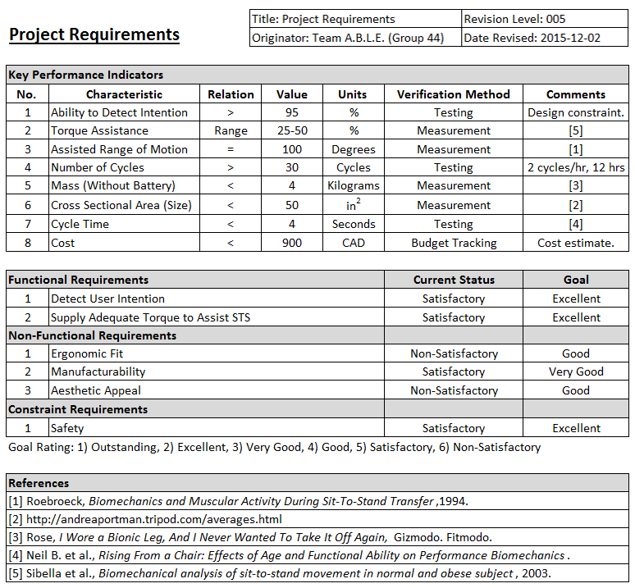

## Obsolete Project Requirements

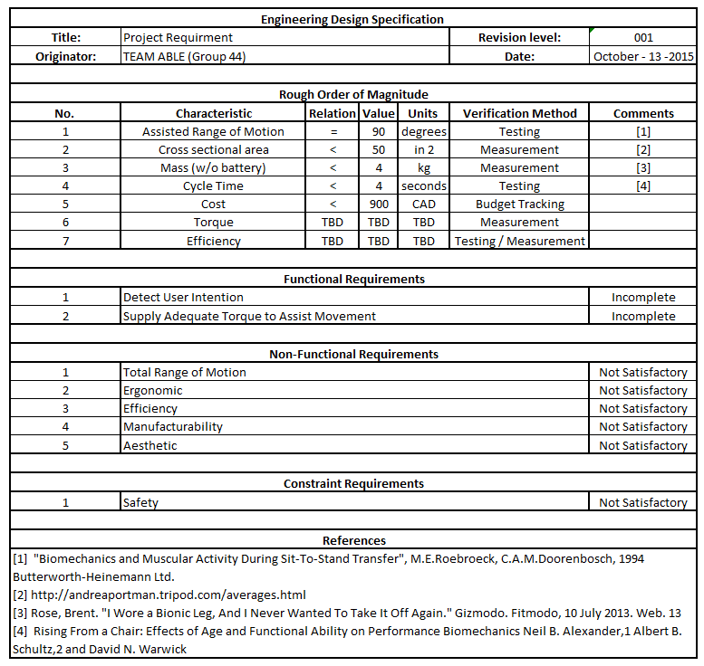

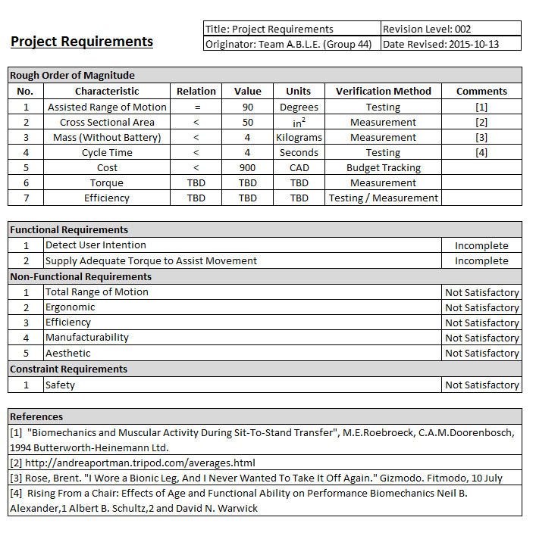

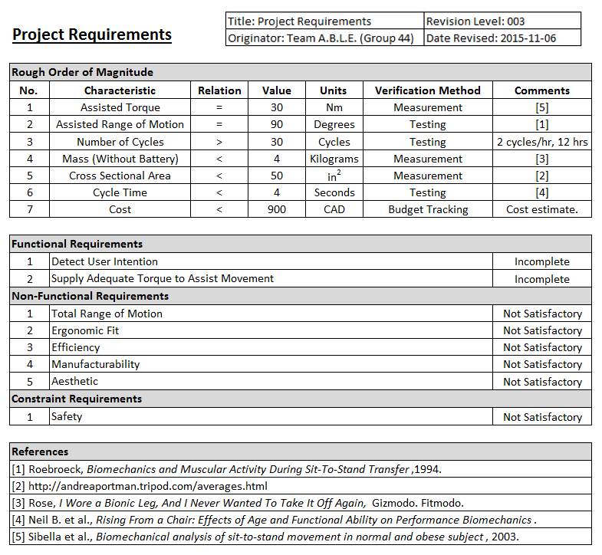

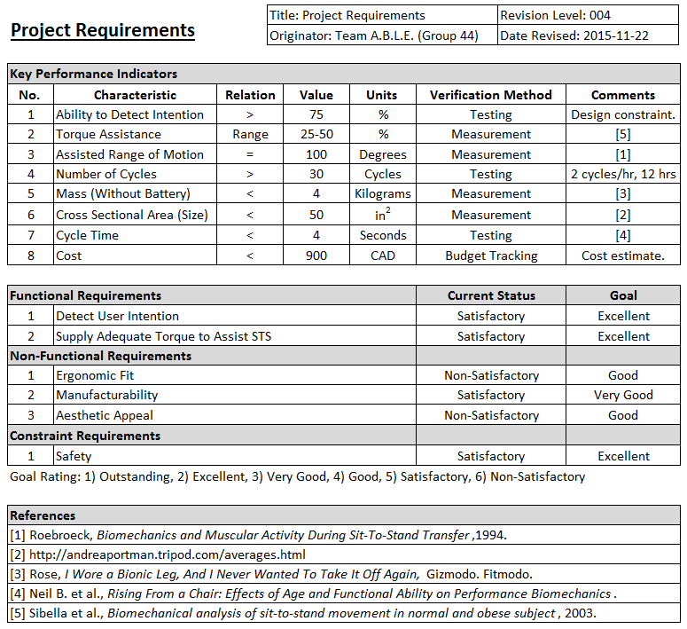

## SENIAM Recommendations for EMG use

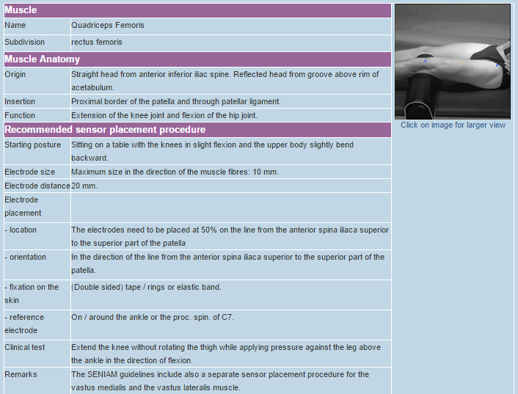

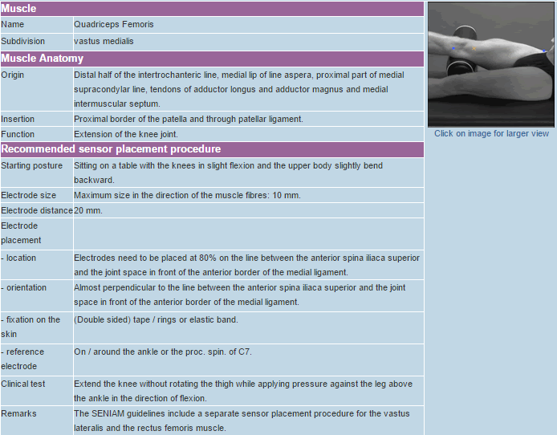

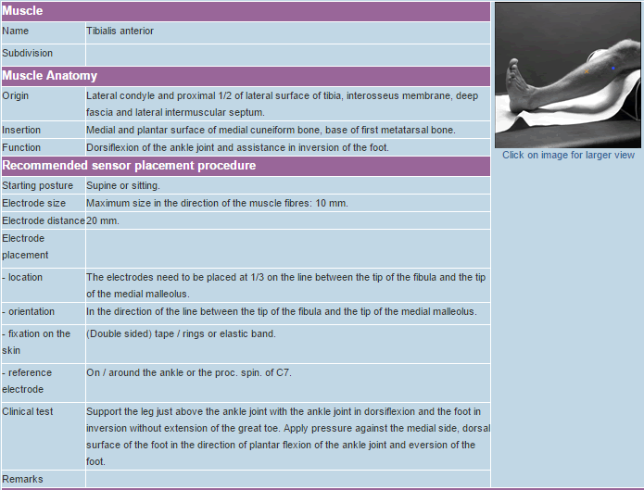

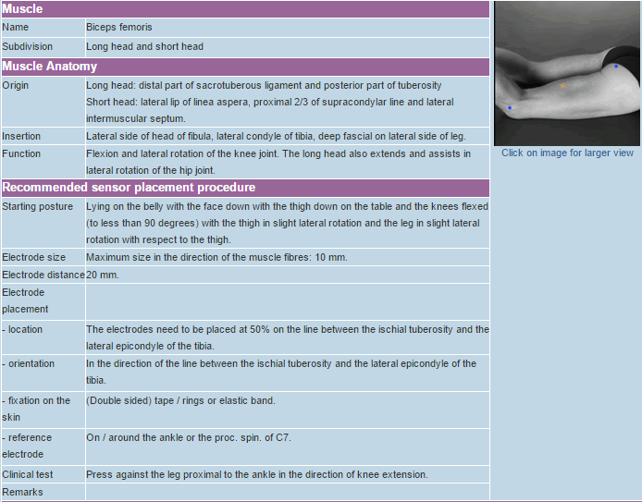

## Calculations for Concept 1: Linear Actuation

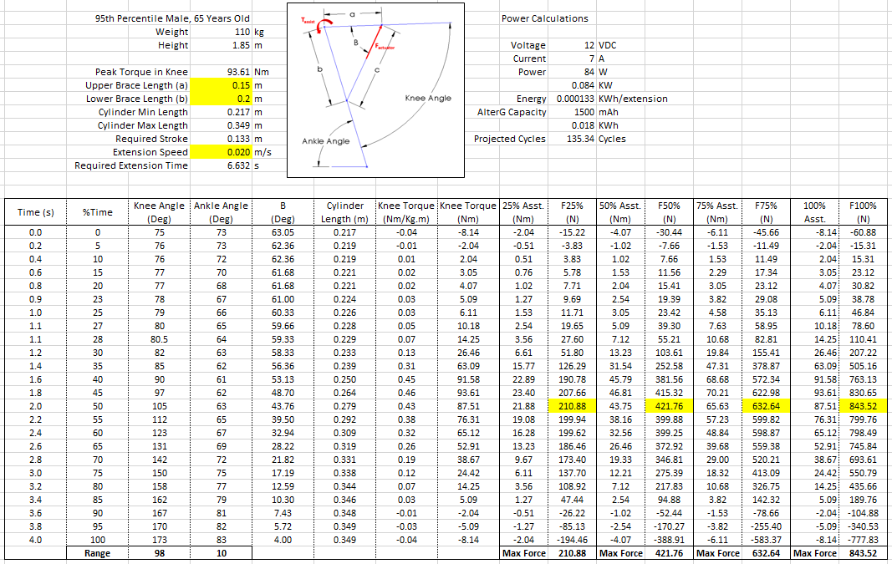

## Calculations for Concept 3: Pull Actuation

Results of the calculations from Section 6.9.2.



Values for the knee torque are from Roebroek et al., 1994 [22].

# Appendix B – Design Project Management Data

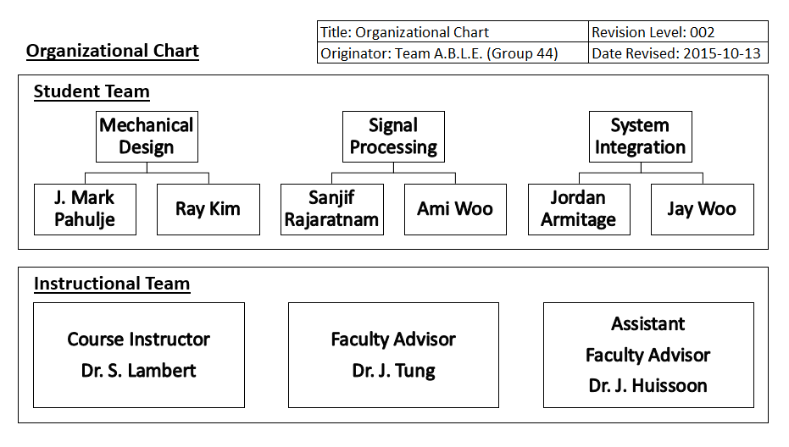



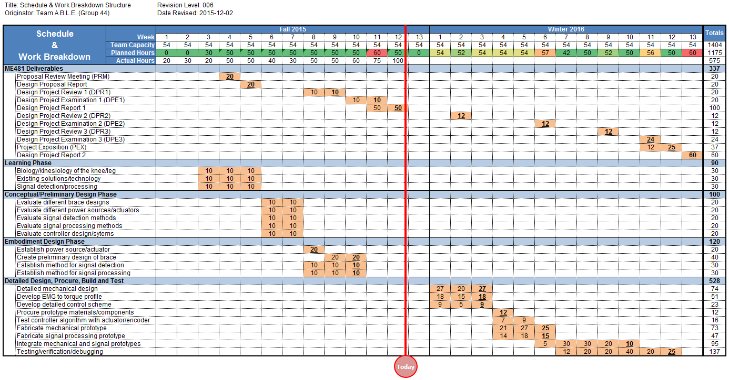

# Appendix C- MyoWare Specifications

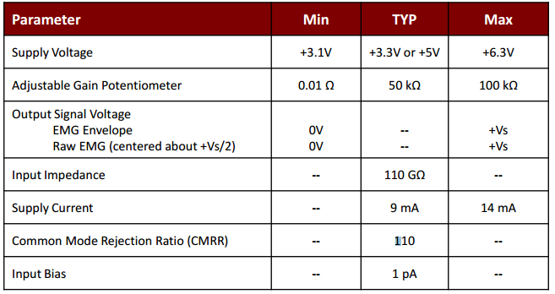

# Appendix D– MATLAB Code used for Signal Processing

%% Set Points

sampling\_frequency = 1024; % Hz

low\_cutoff = 5; % Hz

high\_cutoff = 15; % Hz

norder = 2;

%% Part 1 - Preliminary Testing %%

A = csvread('QF1stTrial.csv',4,0);

Angle = A(:,2); % local - Axis Angle Signals

Gyro = A(:,15); % deg/sec\* - Gyroscope Signals

Accel = A(:,23); % m/(sec^2)\* - Accelerometer Signals

t = A(:,39); % mSecs - Time

RF = A(:,7); % mVolts - Rectus Femoris EMG Signals

%% Plot Raw Signal

figure(1);clf;

plot(t,RF,'k');

axis tight;

xlabel('Time [mSec]');

ylabel('EMG Signal [mV]');

%% Remove Mean from Data - High Pass Butterworth Filter

[RF] = meanf(RF);

[RF] = highpf(RF,sampling\_frequency,high\_cutoff,norder);

figure(2);clf;

plot(t,RF,'k');

axis tight;

xlabel('Time [mSec]');

ylabel('EMG Signal [mV]');

%% Rectification - Low Pass Filtered - Normalized

[RF] = rect(RF);

[RF] = lowpf(RF,sampling\_frequency,low\_cutoff,norder);

[RF] = normal(RF);

figure(3);clf;

plot(t,RF,'k');

axis tight;

xlabel('Time [mSec]');

ylabel('% MVC');

%% Plotting Axis Angle Data

figure(4);clf;

plot(t,Angle,'k');

axis tight;

xlabel('Time [mSec]');

ylabel('Axis Angle');

%% Plotting Gyroscope Data

figure(5);clf;

plot(t,Gyro,'k');

axis tight;

xlabel('Time [mSec]');

ylabel('Gyroscope Signal [deg/sec]');

%% Plotting Accelerometer Data

figure(6);clf;

plot(t,Accel,'k');

axis tight;

xlabel('Time [mSec]');

ylabel('Accelerometer Signal [m/(sec^2)\*]');

%% Combining Plots

figure(7);clf;

Gyro = 0.75\*Gyro;

Accel = 125\*Accel - min(125\*Accel)-111;

Angle = 500\*Angle - min(500\*Angle)-85;

plot(t,RF,'b',t,Angle,'k',t,Gyro,'g',t,Accel,'r');

axis tight;

legend('Rectus Femoris','Axis Angle','Gyroscope','Accel');

xlabel('Time [mSec]');

ylabel('% MVC');

%% Part 2 - Secondary Testing %%

A = csvread('TotalData.csv',2,0);

t = A(:,1); % mSec - Time

Accel = A(:,6); % m/(sec^2); - Accelerometer Signals

Accel = 10\*Accel;

Accel = Accel - min(Accel)-40;

%% Rectus Femoris

EMG = A(:,2); % mVolts

[EMG] = meanf(EMG);

[EMG] = highpf(EMG,sampling\_frequency,high\_cutoff,norder);

[EMG] = rect(EMG);

[EMG] = lowpf(EMG,sampling\_frequency,low\_cutoff,norder);

[EMG] = normal(EMG);

figure(8);clf;

plot(t,EMG,'b',t,Accel,'r');

axis tight;

xlabel('Time [mSec]');

ylabel('% MVC');

legend('Rectus Femoris','Accelerometer');

%% Biceps Femoris

EMG = A(:,3); % mVolts

[EMG] = meanf(EMG);

[EMG] = highpf(EMG,sampling\_frequency,high\_cutoff,norder);

[EMG] = rect(EMG);

[EMG] = lowpf(EMG,sampling\_frequency,low\_cutoff,norder);

[EMG] = normal(EMG);

figure(9);clf;

plot(t,EMG,'b',t,Accel,'r');

axis tight;

xlabel('Time [mSec]');

ylabel('% MVC');

legend('Biceps Femoris','Accelerometer');

%% Tibialis Anterior

EMG = A(:,4); % mVolts

[EMG] = meanf(EMG);

[EMG] = highpf(EMG,sampling\_frequency,high\_cutoff,norder);

[EMG] = rect(EMG);

[EMG] = lowpf(EMG,sampling\_frequency,low\_cutoff,norder);

[EMG] = normal(EMG);

figure(10);clf;

plot(t,EMG,'b',t,Accel,'r');

axis tight;

xlabel('Time [mSec]');

ylabel('% MVC');

legend('Tibialis Anterior','Accelerometer');

%% Vastus Medialis

EMG = A(:,5); % mVolts

[EMG] = meanf(EMG);

[EMG] = highpf(EMG,sampling\_frequency,high\_cutoff,norder);

[EMG] = rect(EMG);

[EMG] = lowpf(EMG,sampling\_frequency,low\_cutoff,norder);

[EMG] = normal(EMG);

figure(11);clf;

plot(t,EMG,'b',t,Accel,'r');

axis tight;

xlabel('Time [mSec]');

ylabel('% MVC');

legend('Vastus Medialis','Accelerometer');

## D1 Remove Mean (meanf) Function

function[X\_filtered]=meanf(X)

Xmean = mean(X);

X\_filtered = X - Xmean;

## D2 High Pass Butterworth Filter (highpf) Function

function [X\_filtered] = highpf(X, sample,high,n)

hWn = high/sample\*2;

[b,a] = butter(n,hWn,'high');

X\_filtered = filtfilt(b,a,X);

## D3 Rectification (rect) Function

function[X\_filtered]=rect(X)

X\_filtered = abs(X);

## D4 Low Pass Butterworth Filter(lowpf) Function

function[X\_filtered]=lowpf(X,sample,low,n)

Wn = low/sample\*2;

[b,a] = butter(n,Wn);

X\_filtered = filtfilt(b,a,X);

## D5 Normalization (normal) Function

function [X\_filtered] = normal(X,Max);

switch nargin

case 2

X\_filtered = X/Max\*100;

case 1

Max = max(abs(X));

X\_filtered = X/Max\*100;

otherwise

X\_filtered = 0;

end

# Appendix E – Exhibits, Testing Video Data

Video of test subject (Ami Woo) performing multiple STS motions with different speed is uploaded to the Google Drive. The links to the video is following:

<https://drive.google.com/file/d/0BxC2keN3Sd_-RVN6bHFpNVcyQWc/view?usp=sharing>